**DHANUSHA MALLAVAJJALA**

**Task 1: Implementing a Simple Firewall**

* **Task 1.A: Implement a Simple Kernel Module**

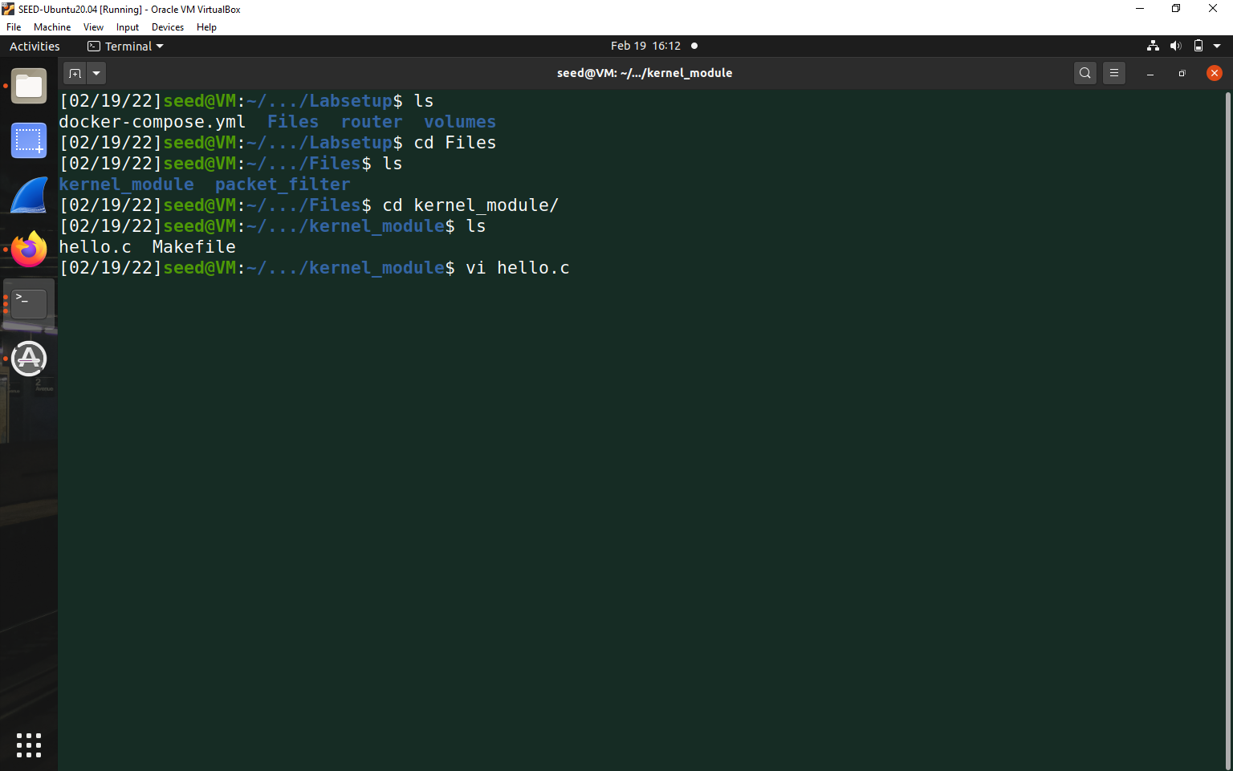

Viewing hello.c program-

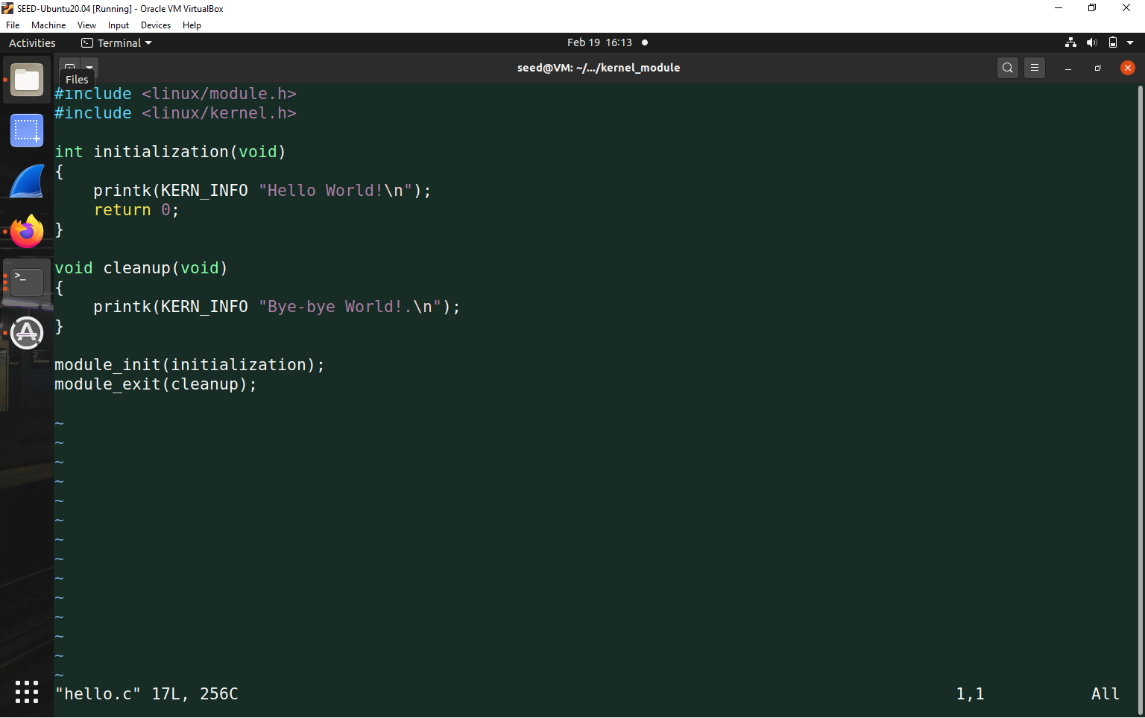

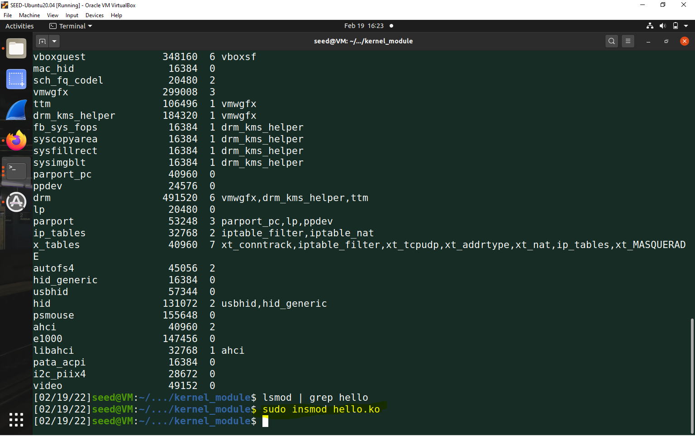 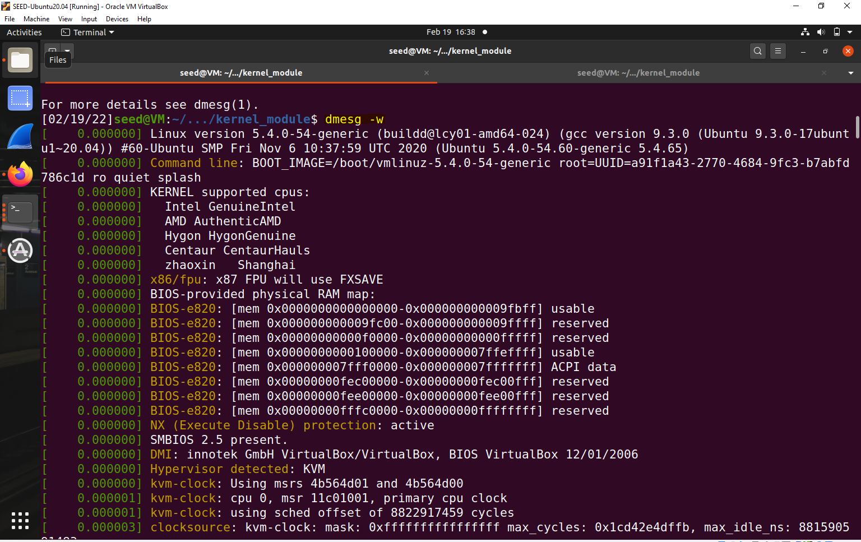

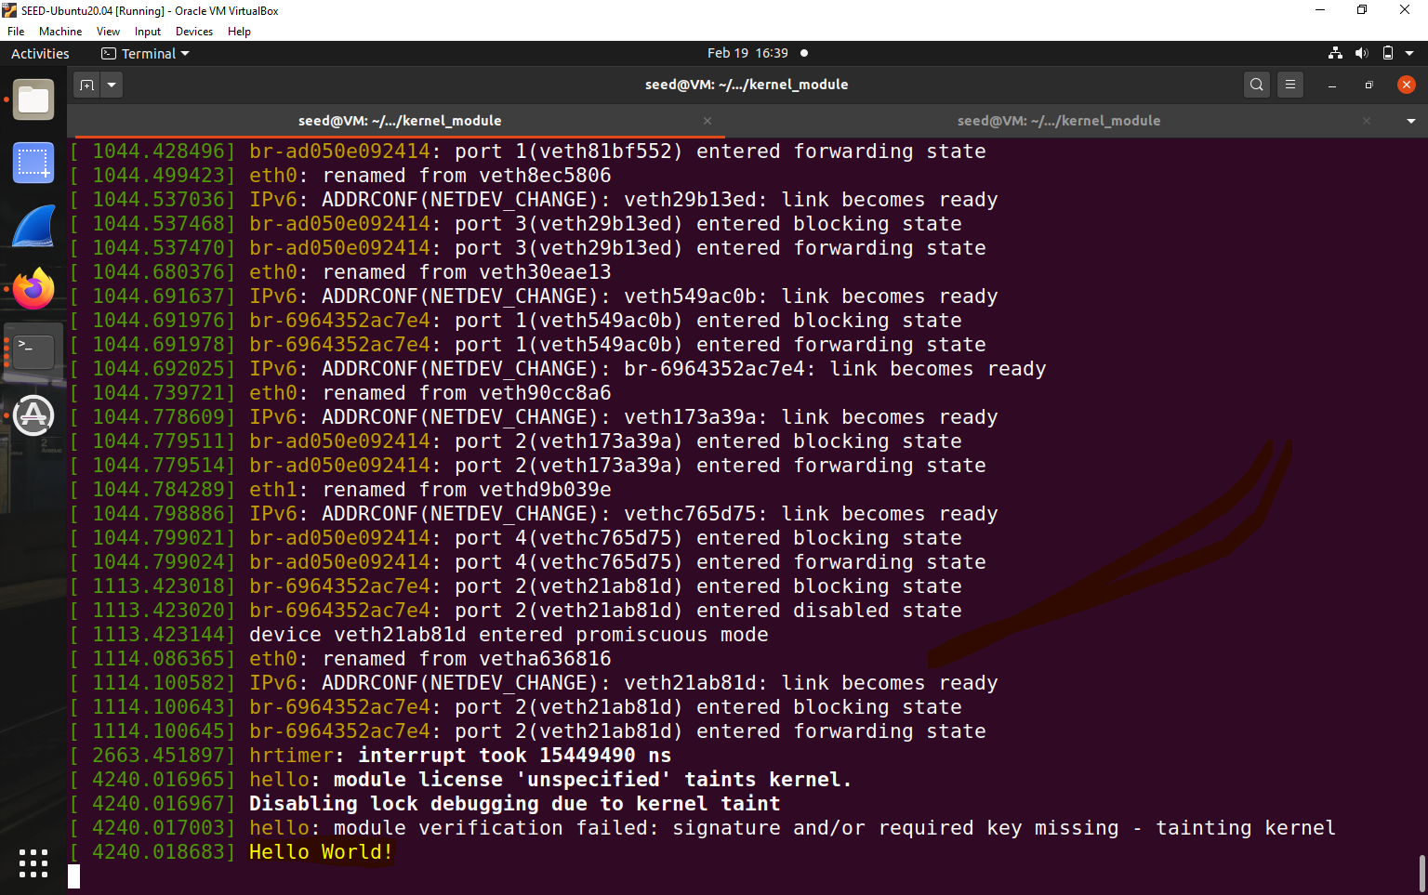

For Bye-Bye World-

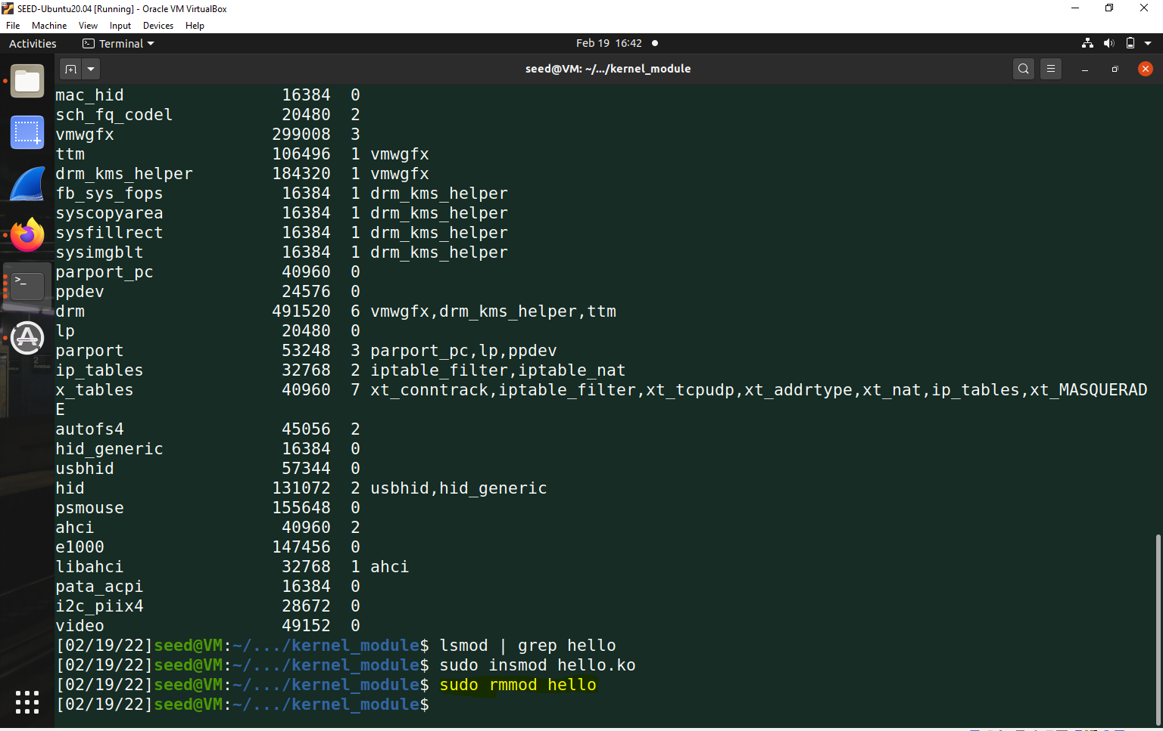

Then use lsmod command

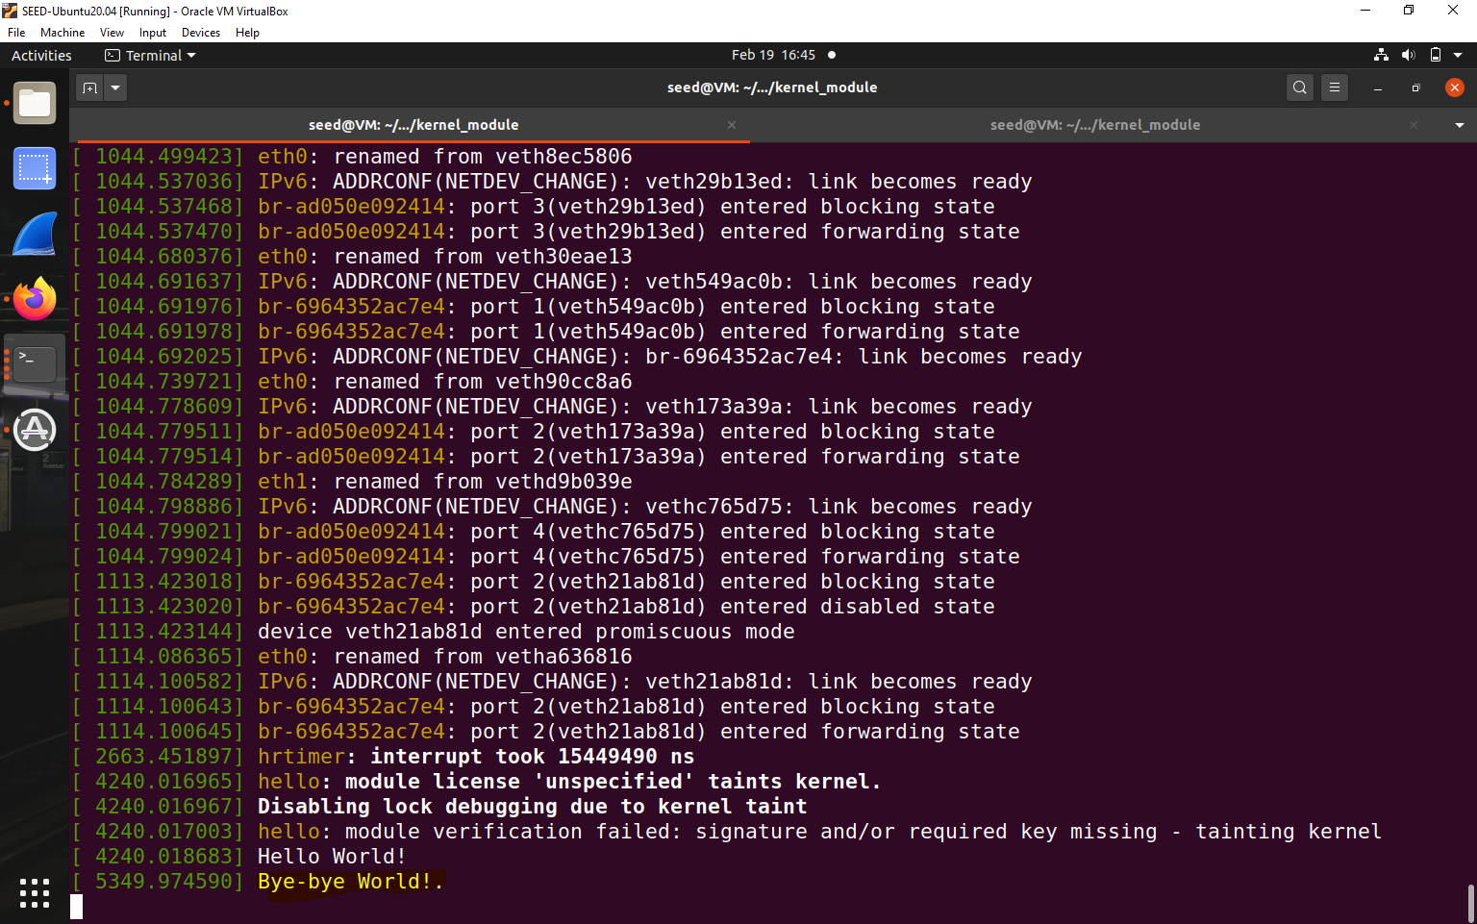

* **Task 1.B: Implement a Simple Firewall UsingNetfilter**

Viewing the code-

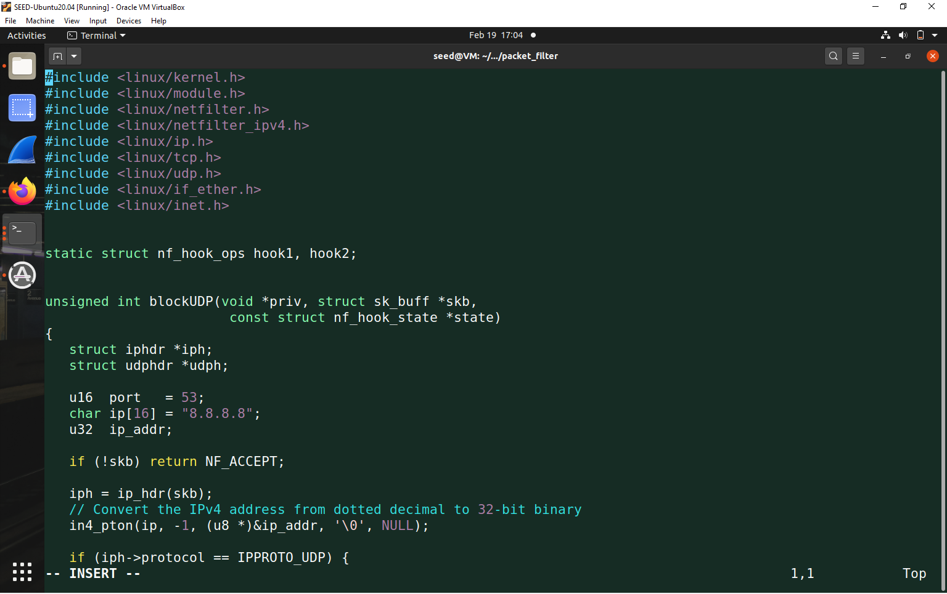

Ping 8.8.8.8 was saying its not reachable

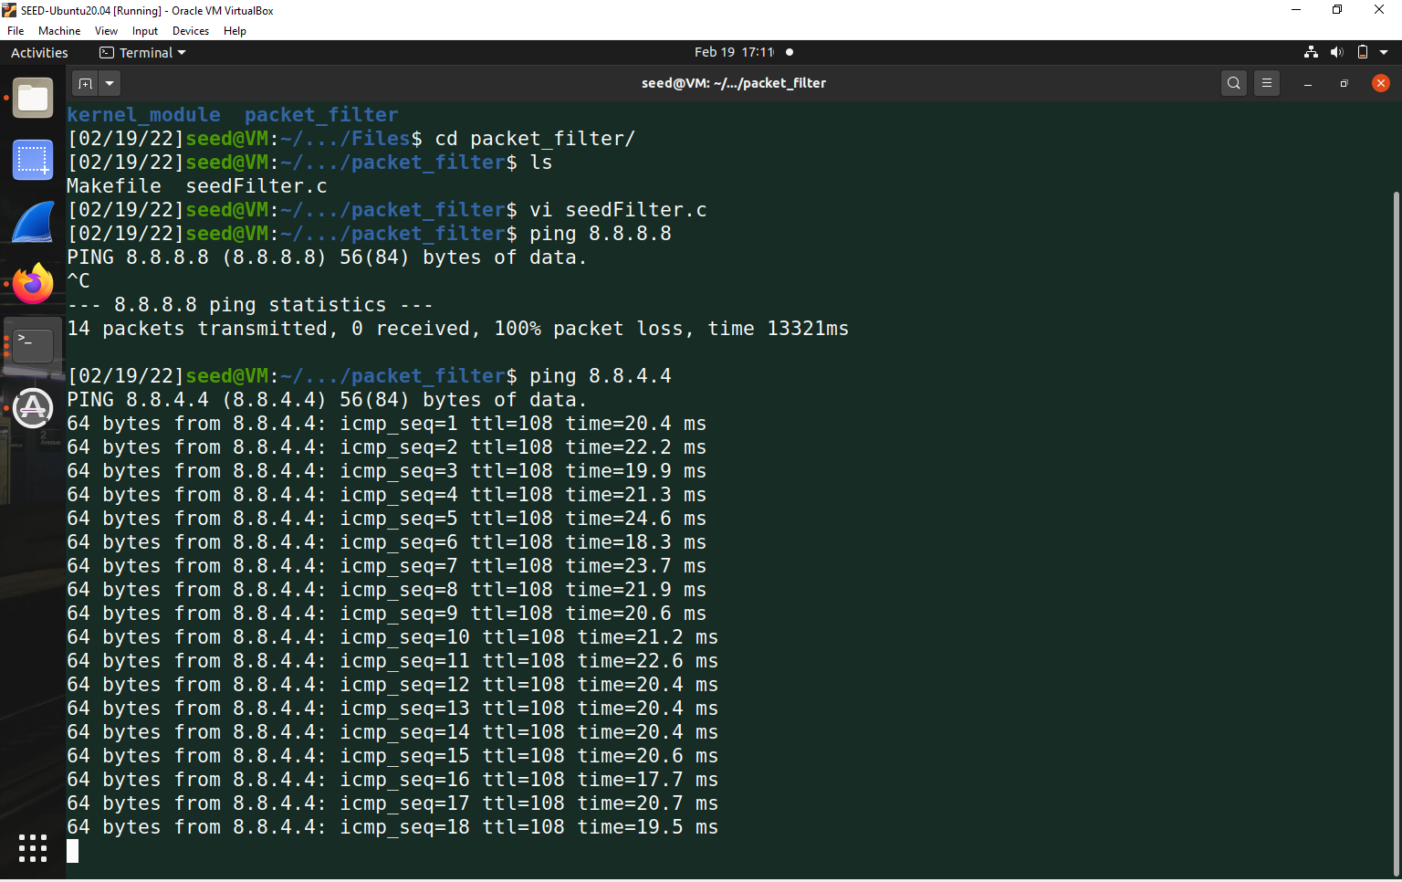

So changed code to 8.8.4.4

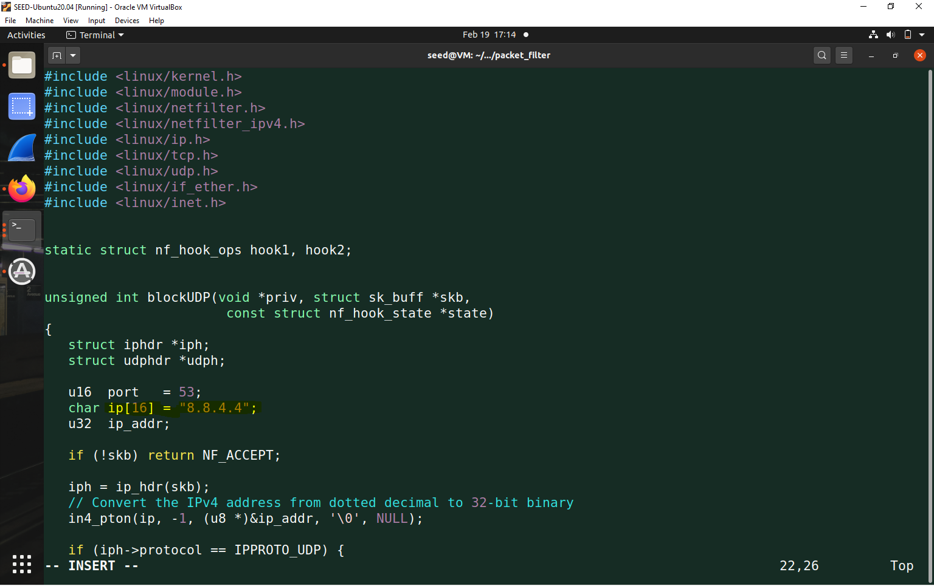

Then we do domain information groper command

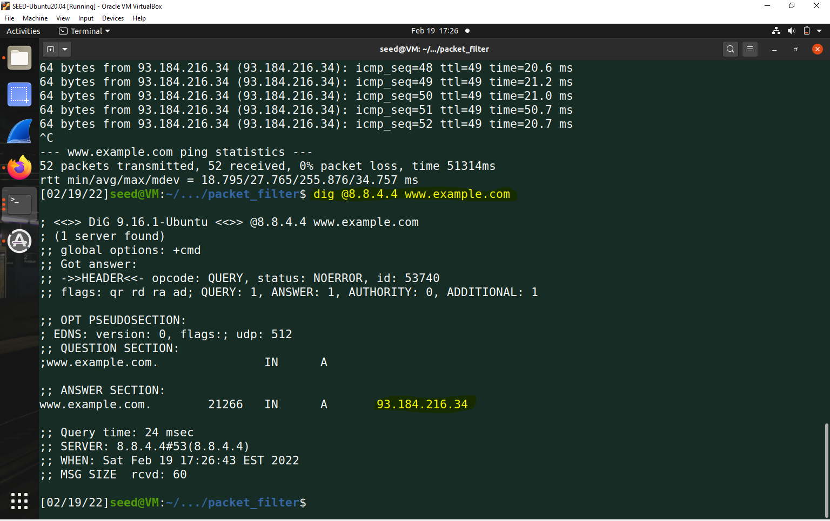

Then we enter make command and then go to kernel module

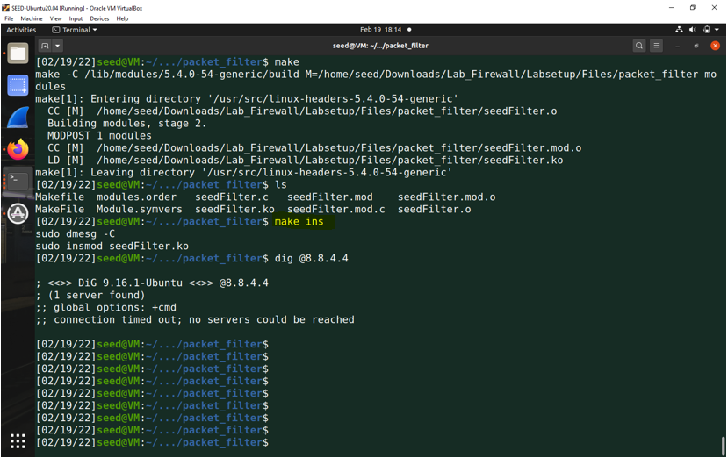

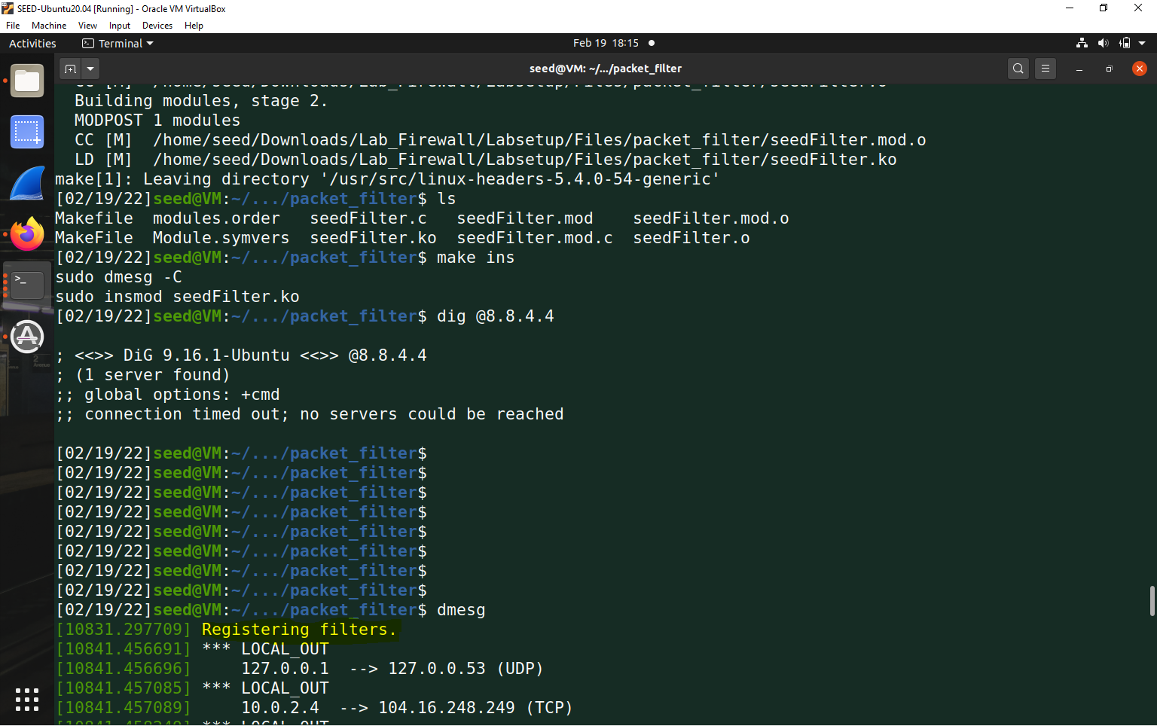

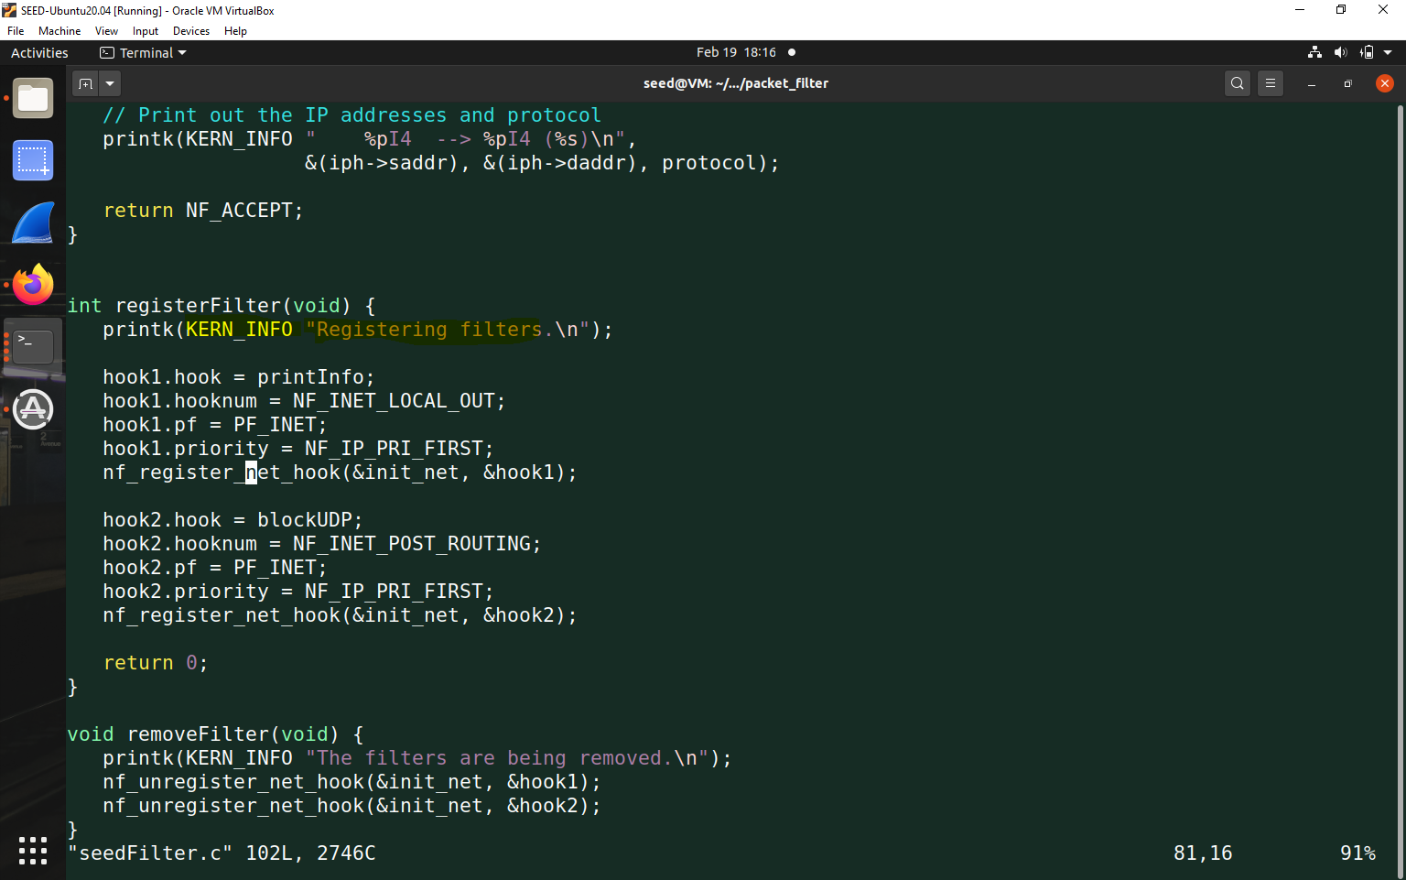

Then our filter will work-

To remove the module use make rm

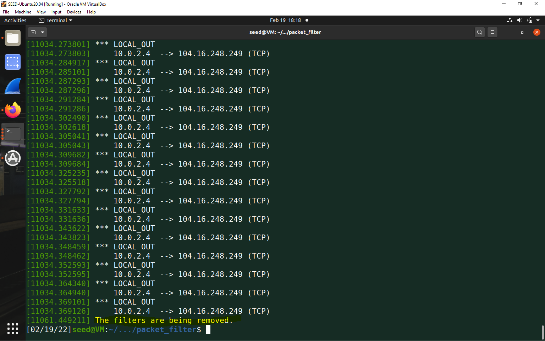

1.2.

Add new hook functions as hook3,hook4,hook5

Register Filter Function

Remove filter function

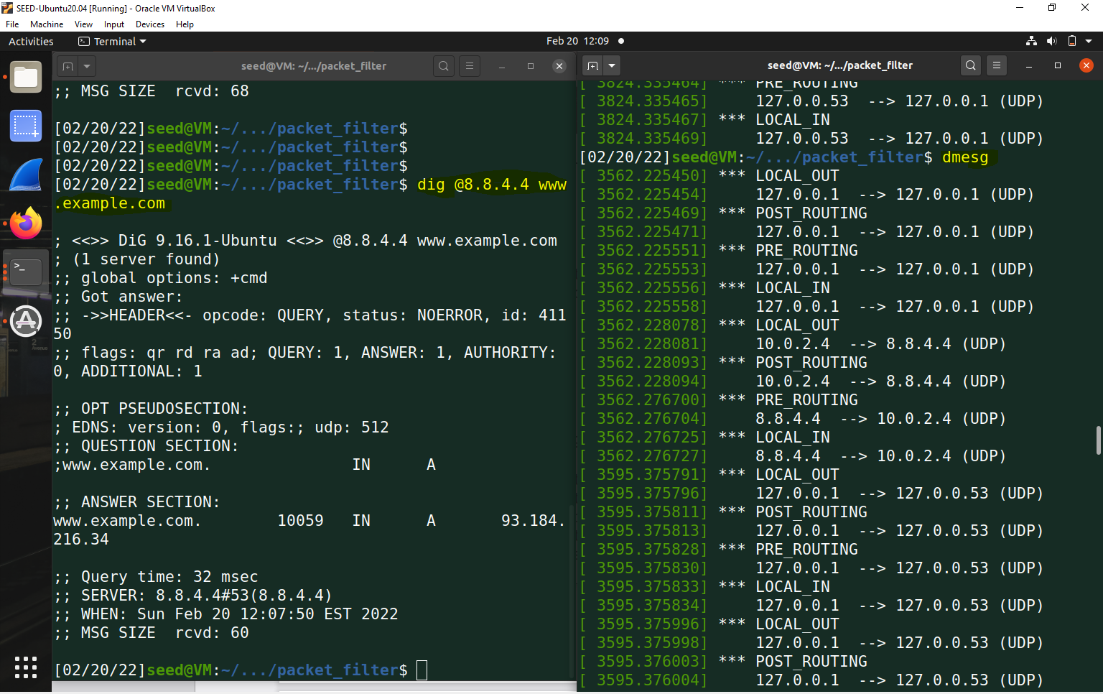

So from above we can see that we did not have forward hook because there is no router setup.

1.3

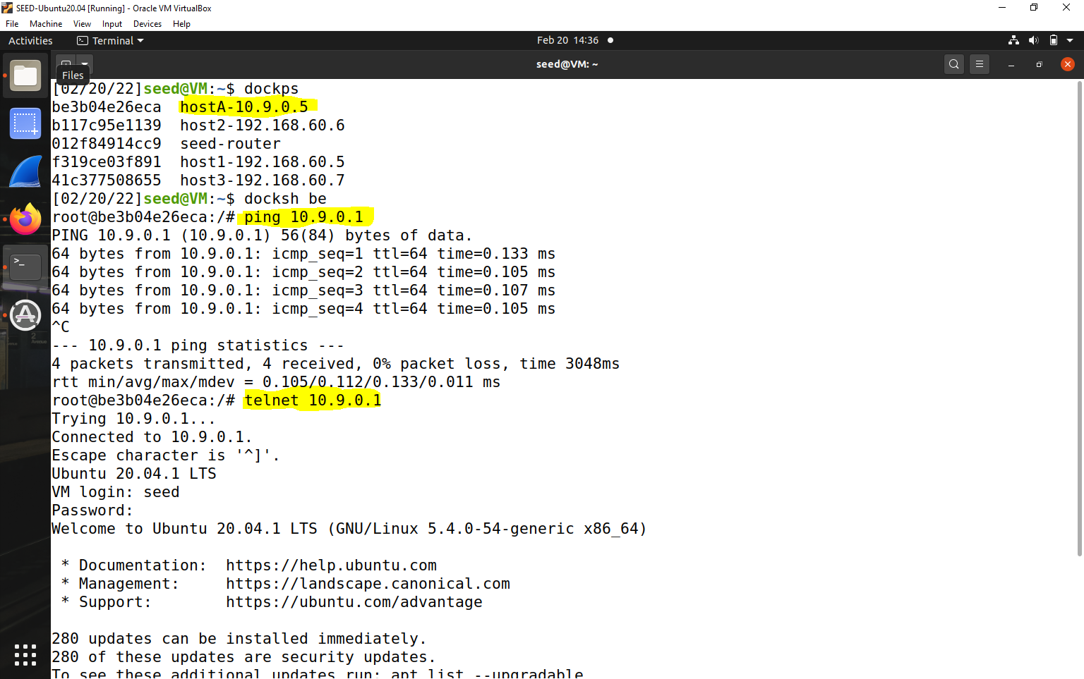



Implementing hook function-

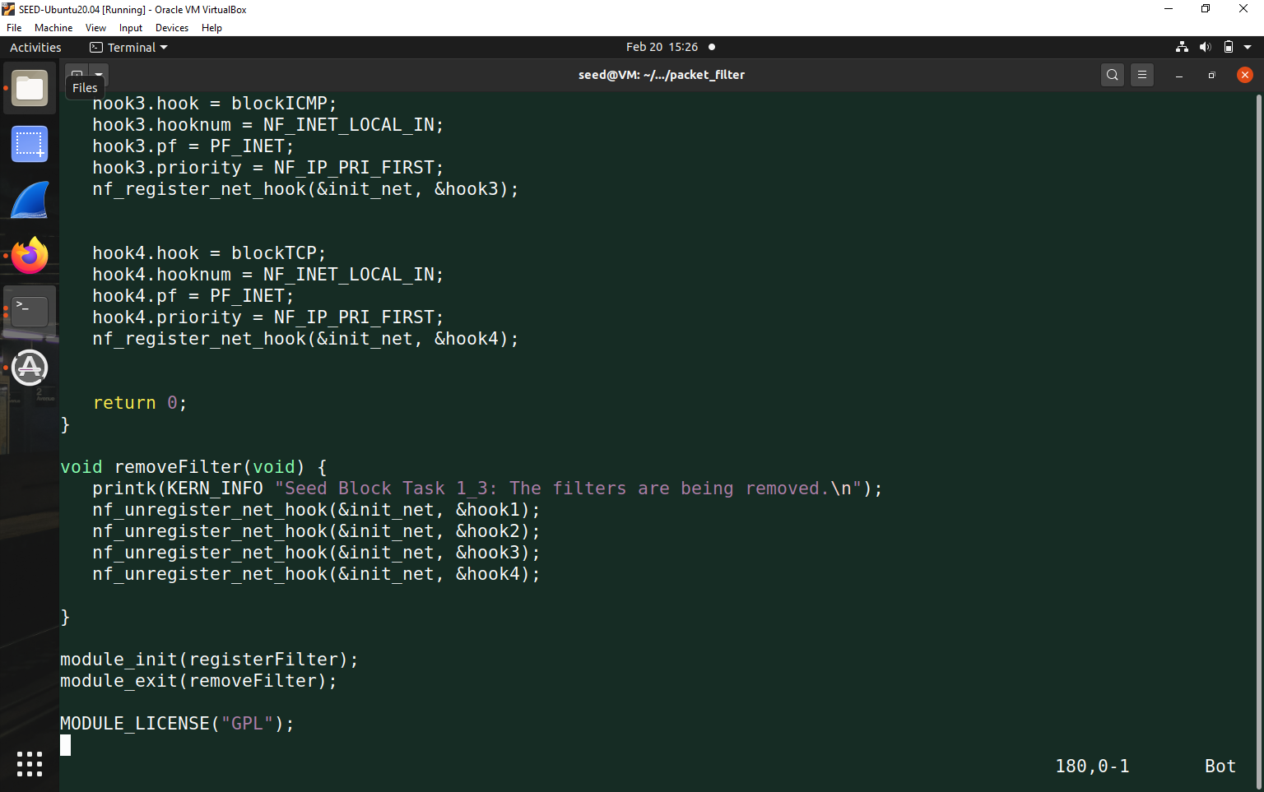

Now we telnet from 10.9.0.5 to 10.9.0.1 and we dmesg in a different container

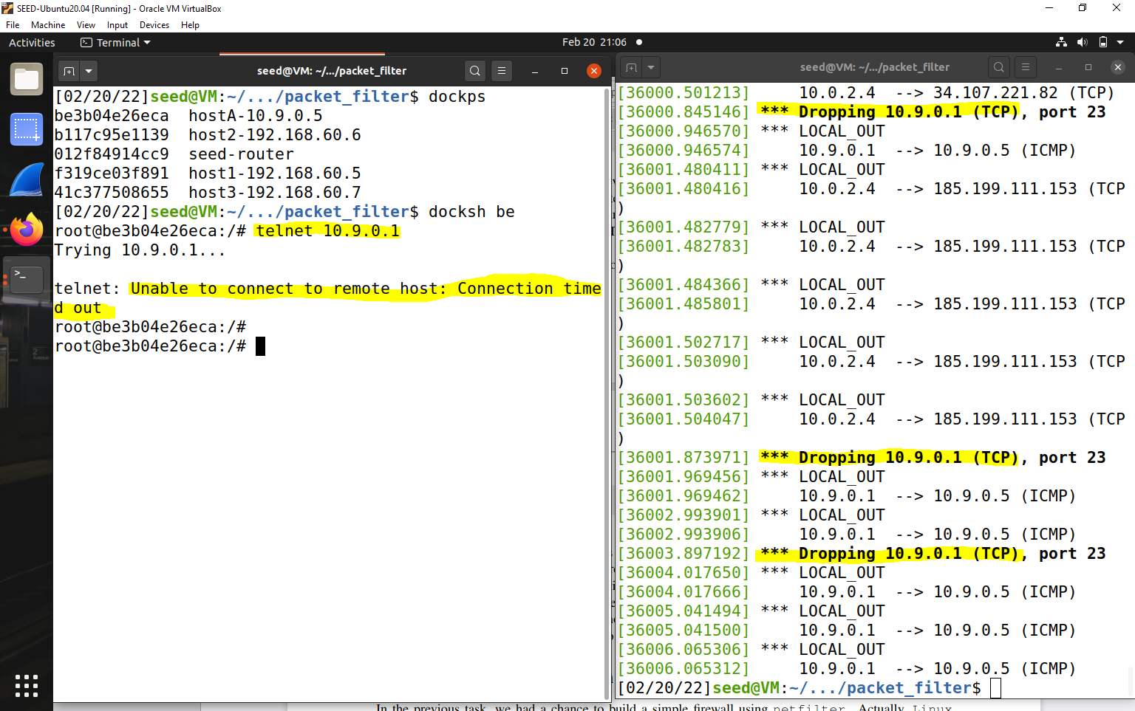



ping 10.9.0.1 from 10.9.0.5

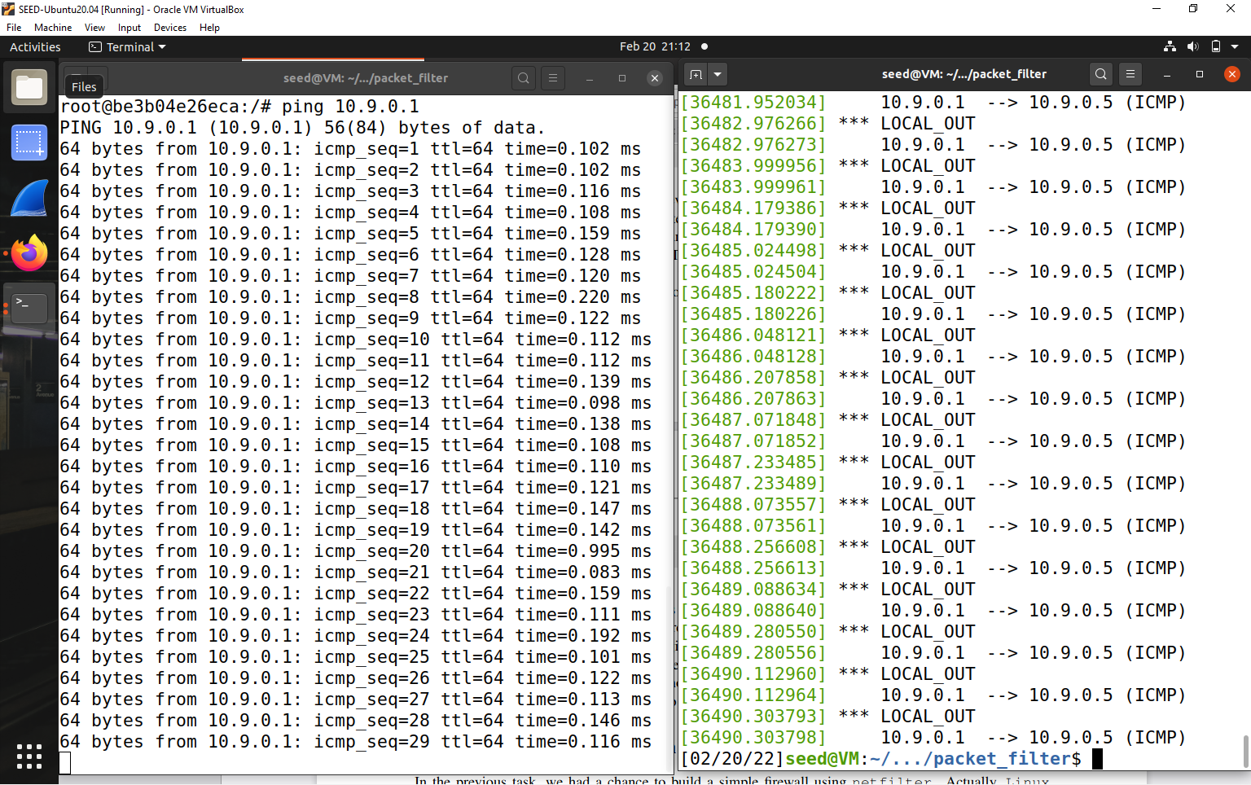

Task 2-

access from 10.9.0.5.

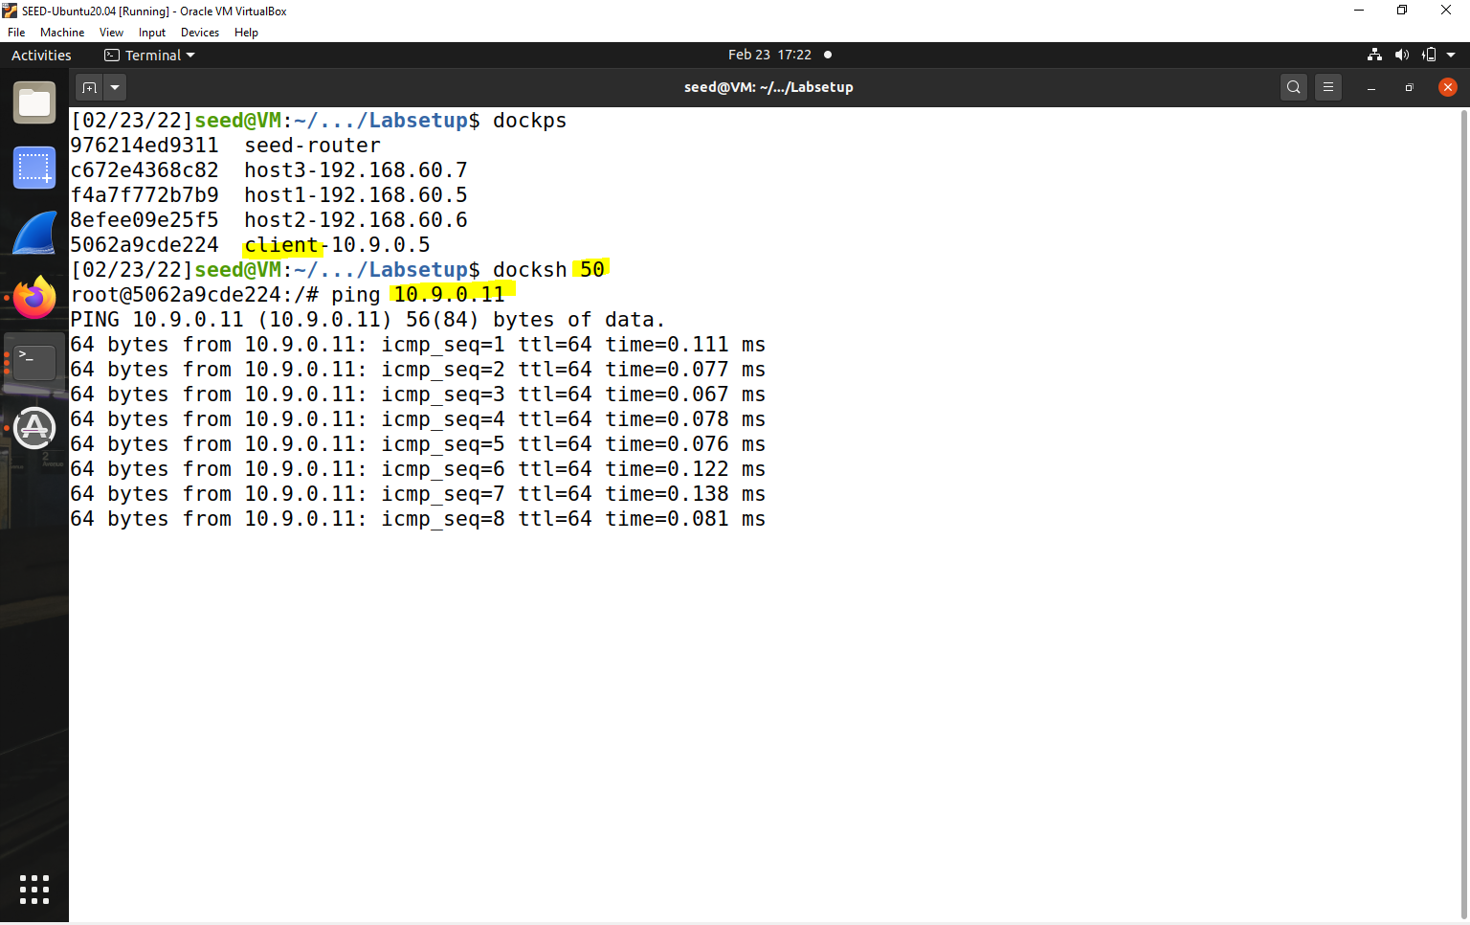



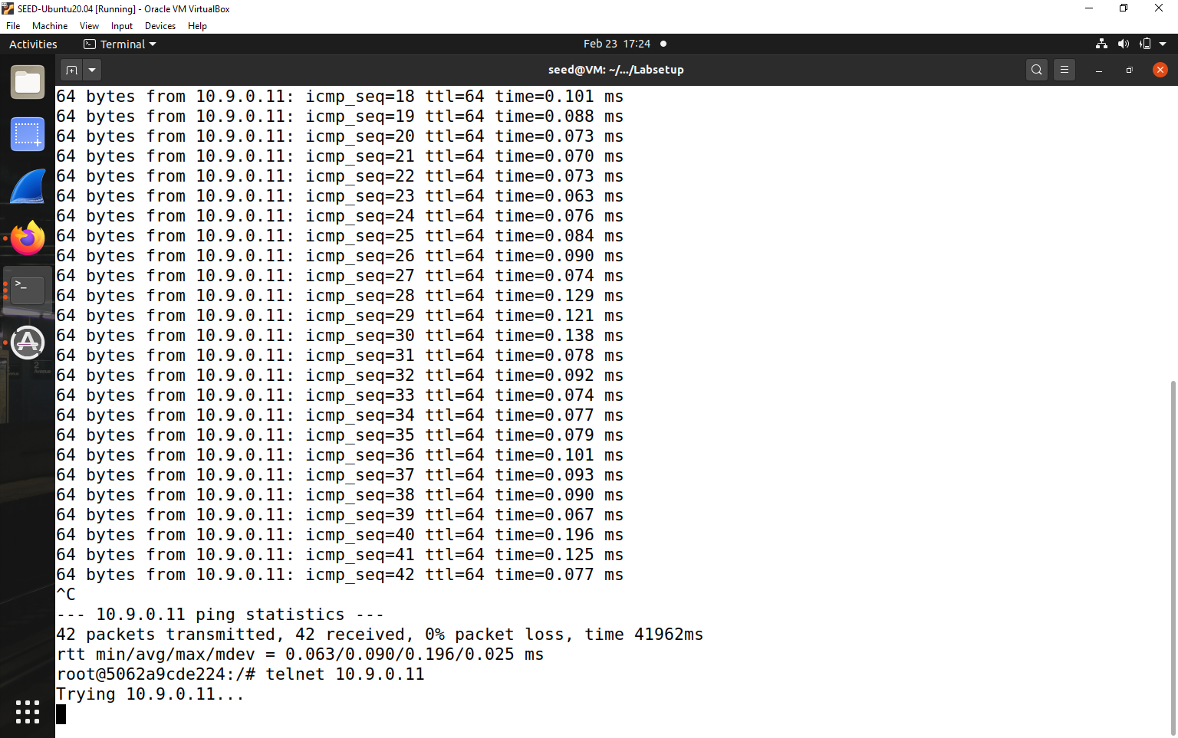

1) Can you ping the router?

Yes I can ping the router

(2) Can you telnet into the router (a telnet server is running on all the containers; an account called seed was created on them with a password dees). –

No.

Explain the purpose -

iptables -A INPUT -p icmp --icmp-type echo-request -j ACCEPT

**In the INPUT chain any ICMP request will be accepted and added to the filter table.**

iptables -A OUTPUT -p icmp --icmp-type echo-reply -j ACCEPT

**In the OUTPUT chain any ICMP response will be accepted and added to the filter table.**

iptables -P OUTPUT DROP //Set default rule for OUTPUT –In the output chain set the default rule to drop everything, other protocols cannot access router

iptables -P INPUT DROP

**Set default rule for INPUT - In the input chain set the default rule to drop everything.**

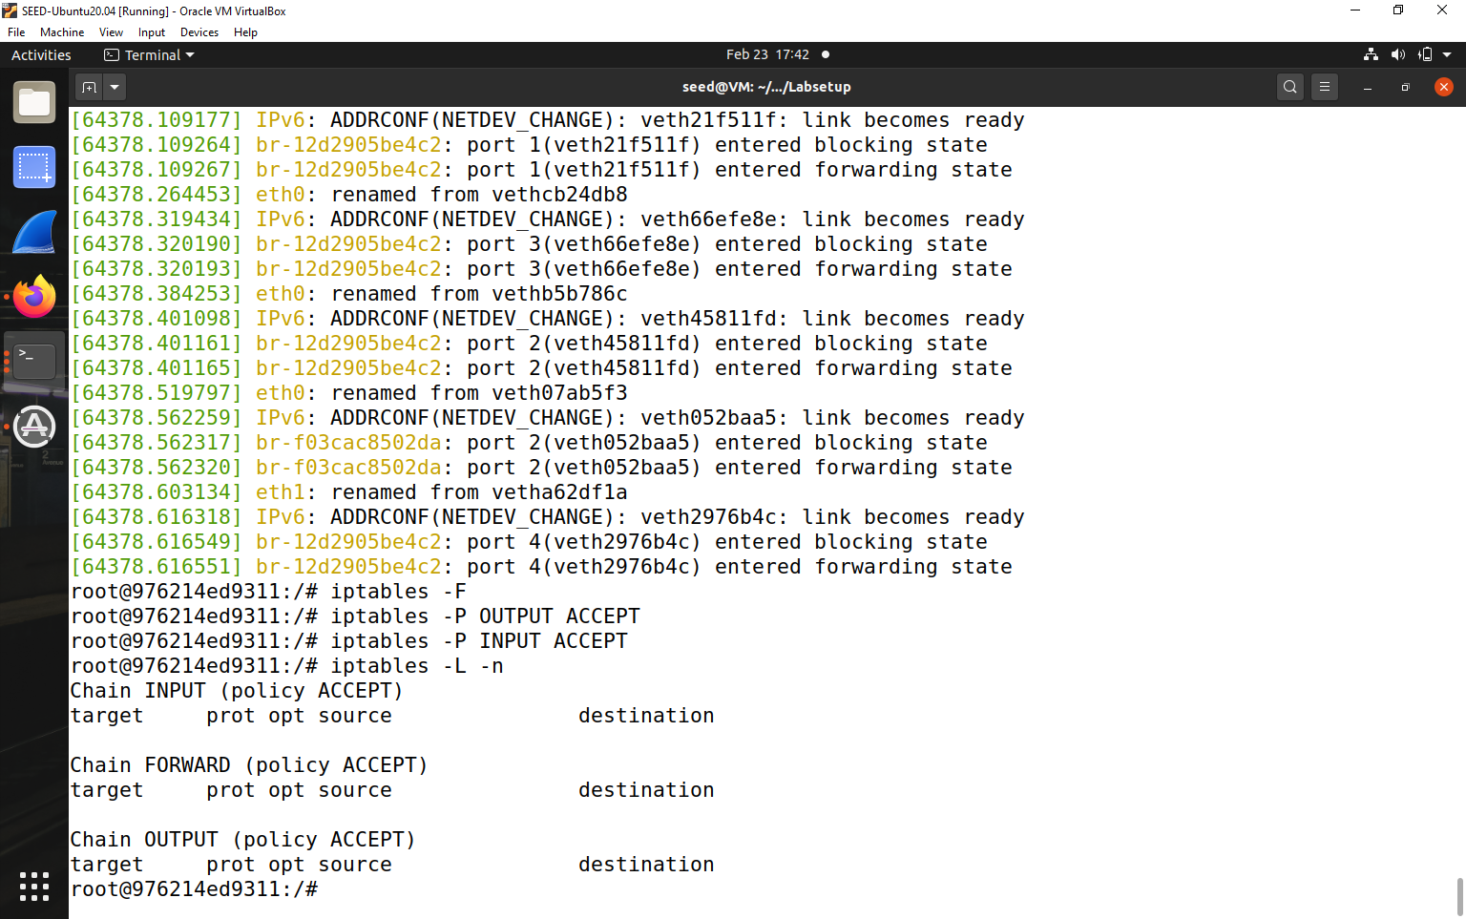

2.B

**Protecting the Internal Network**

1. Outside hosts cannot ping internal hosts.

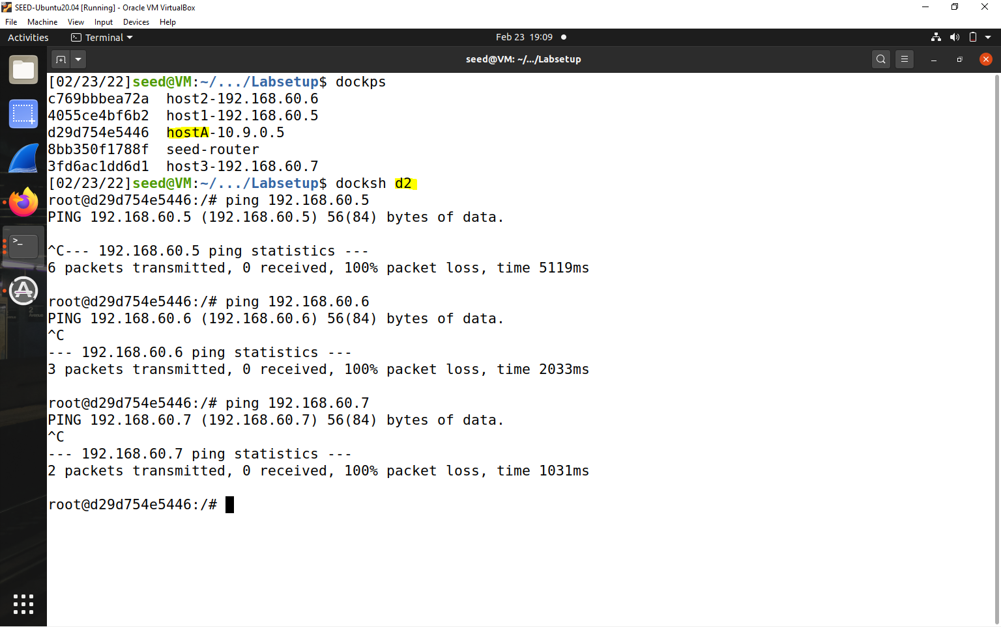



2. Outside hosts can ping the router.

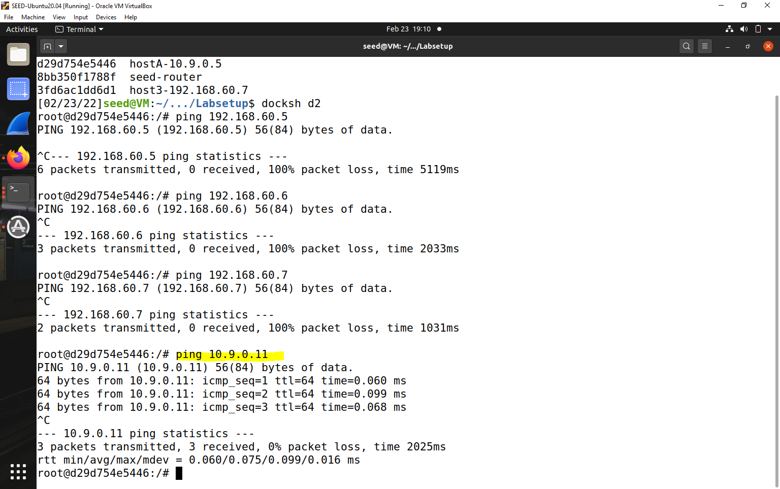



3.Internal hosts can ping outside hosts.

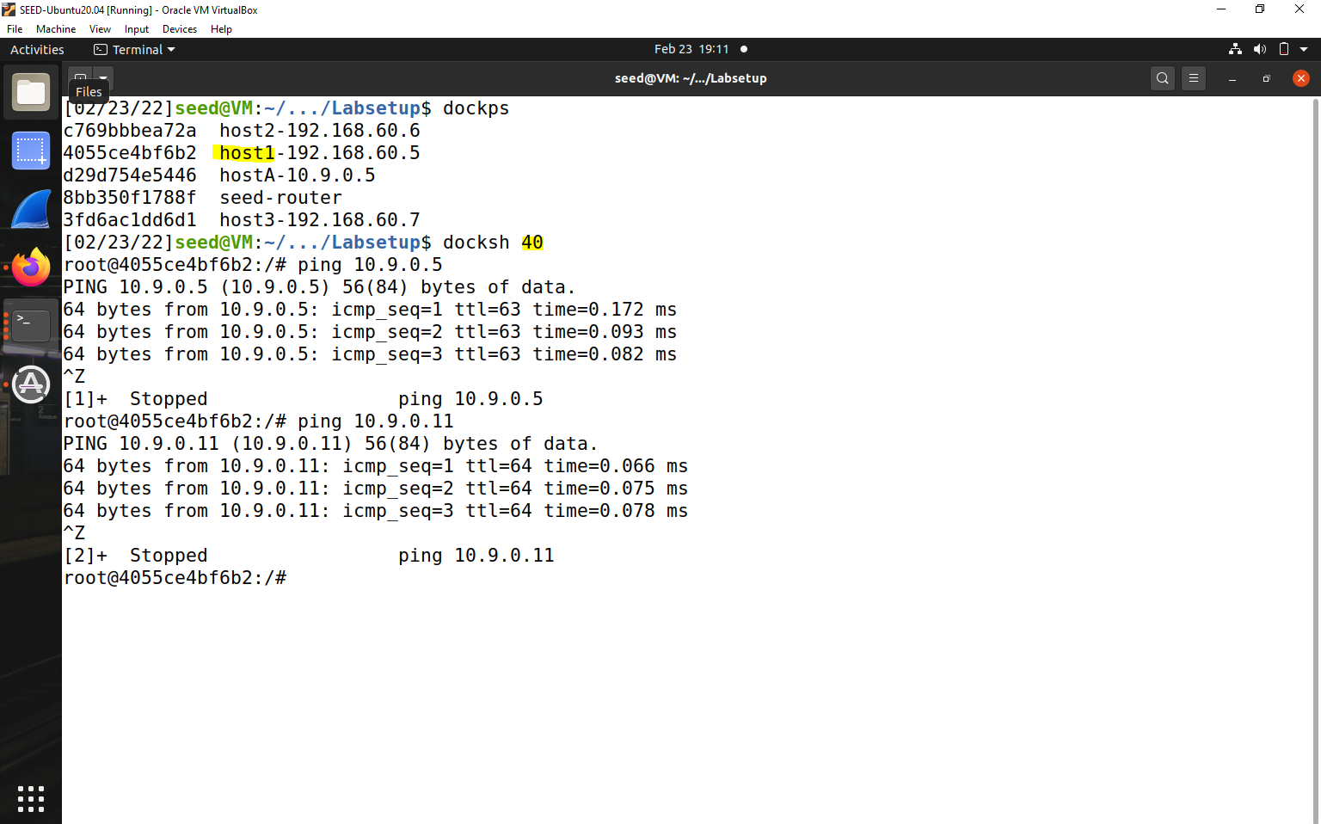



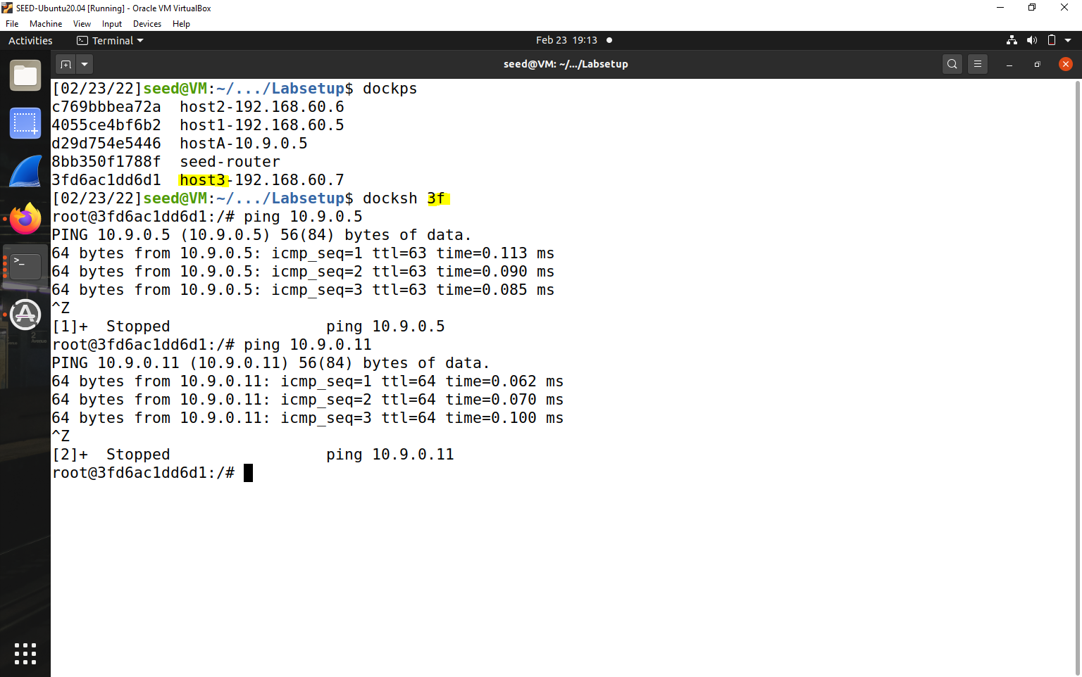



4.All other packets between the internal and external networks should be blocked.

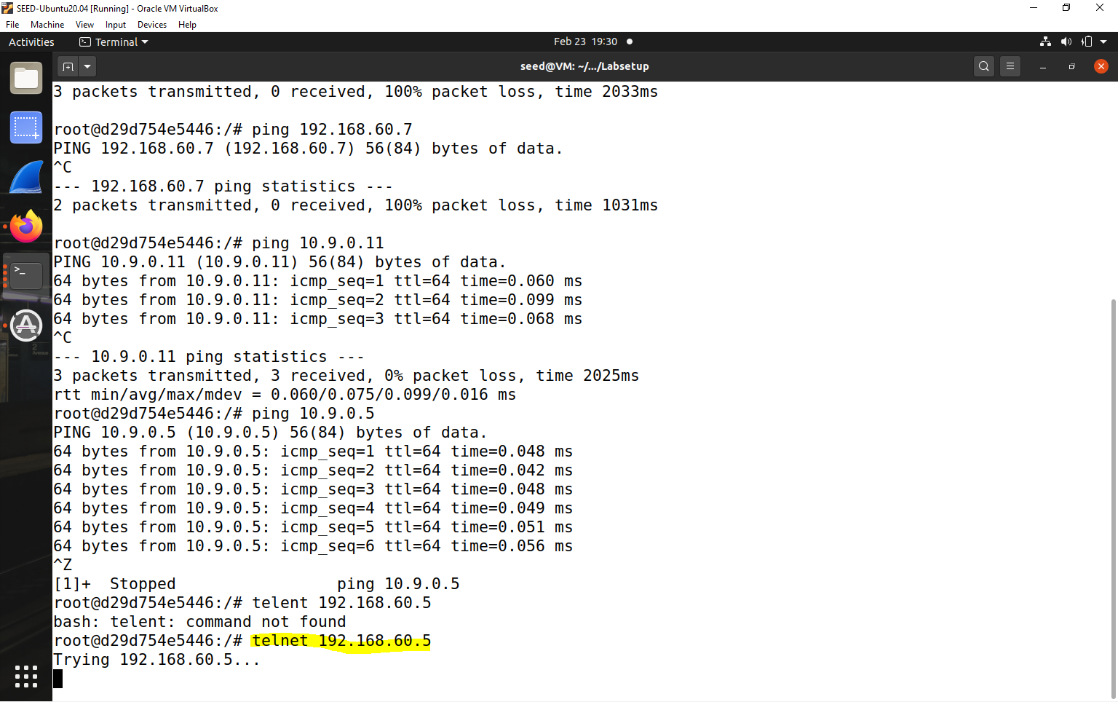



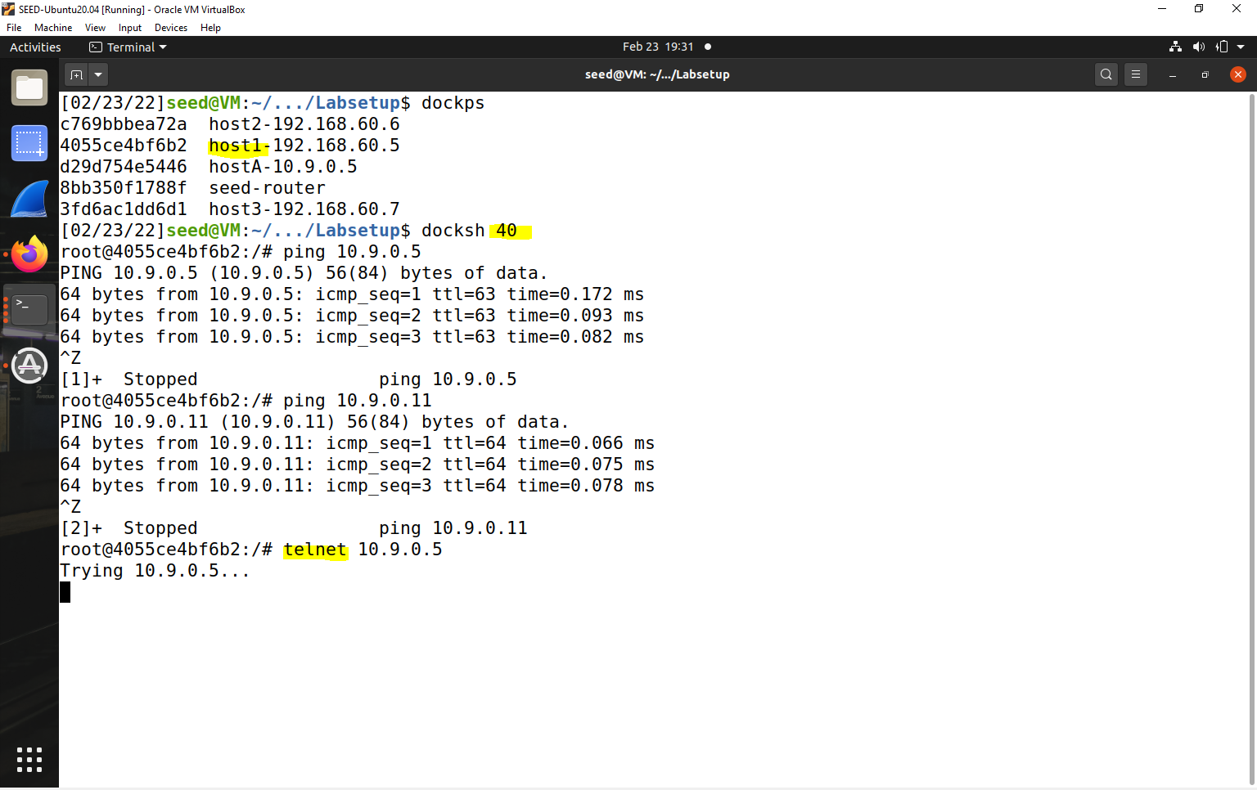



**Task 2.C: Protecting Internal Servers**

1.All the internal hosts run a telnet server (listening to port23). Outside hosts can only access the telnet server on192.168.60.5, not the other internal hosts.

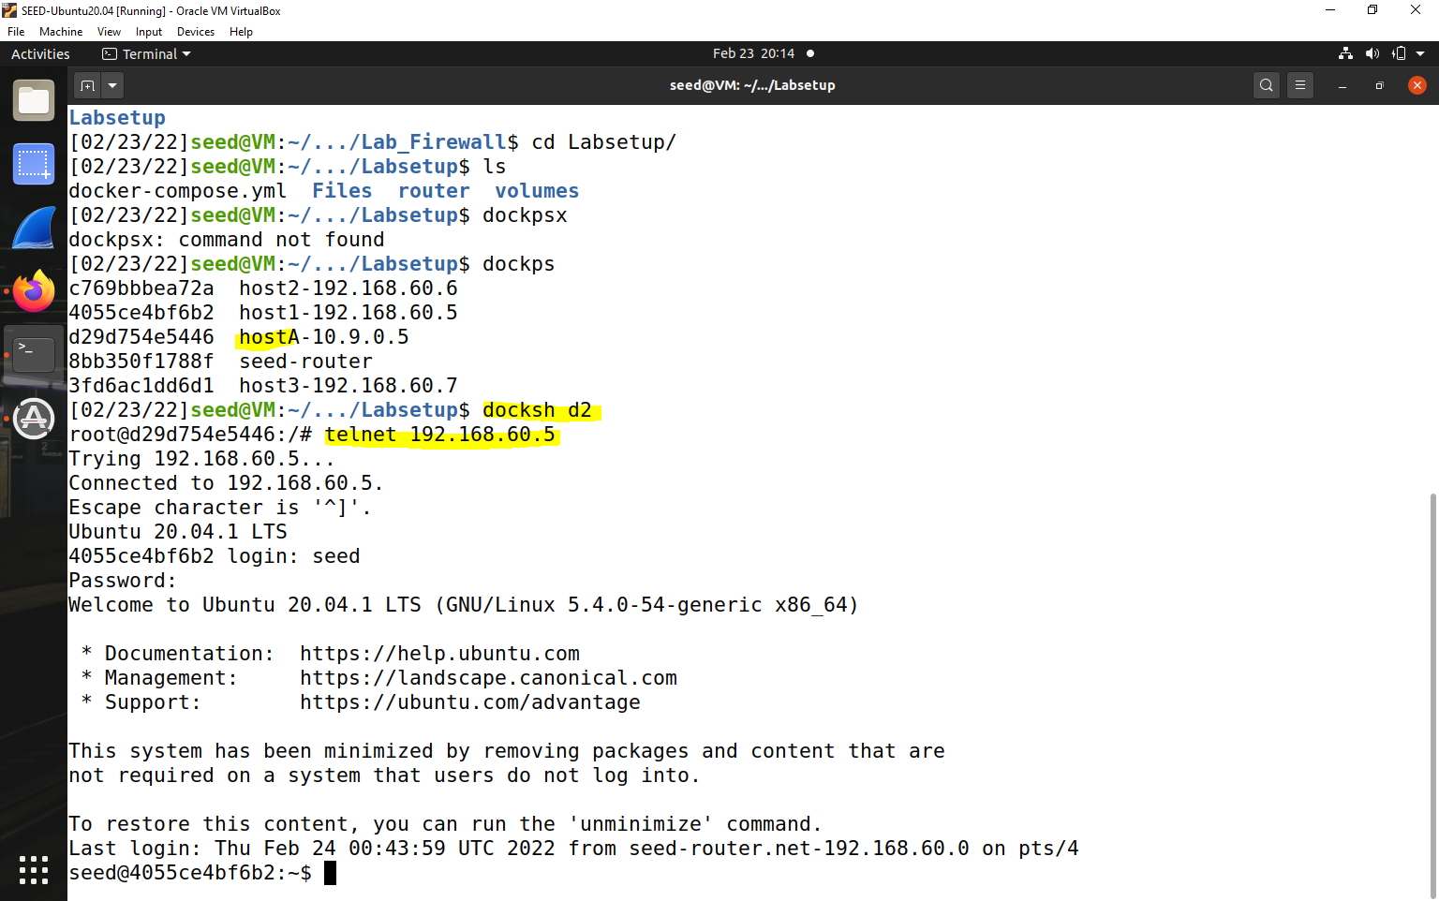



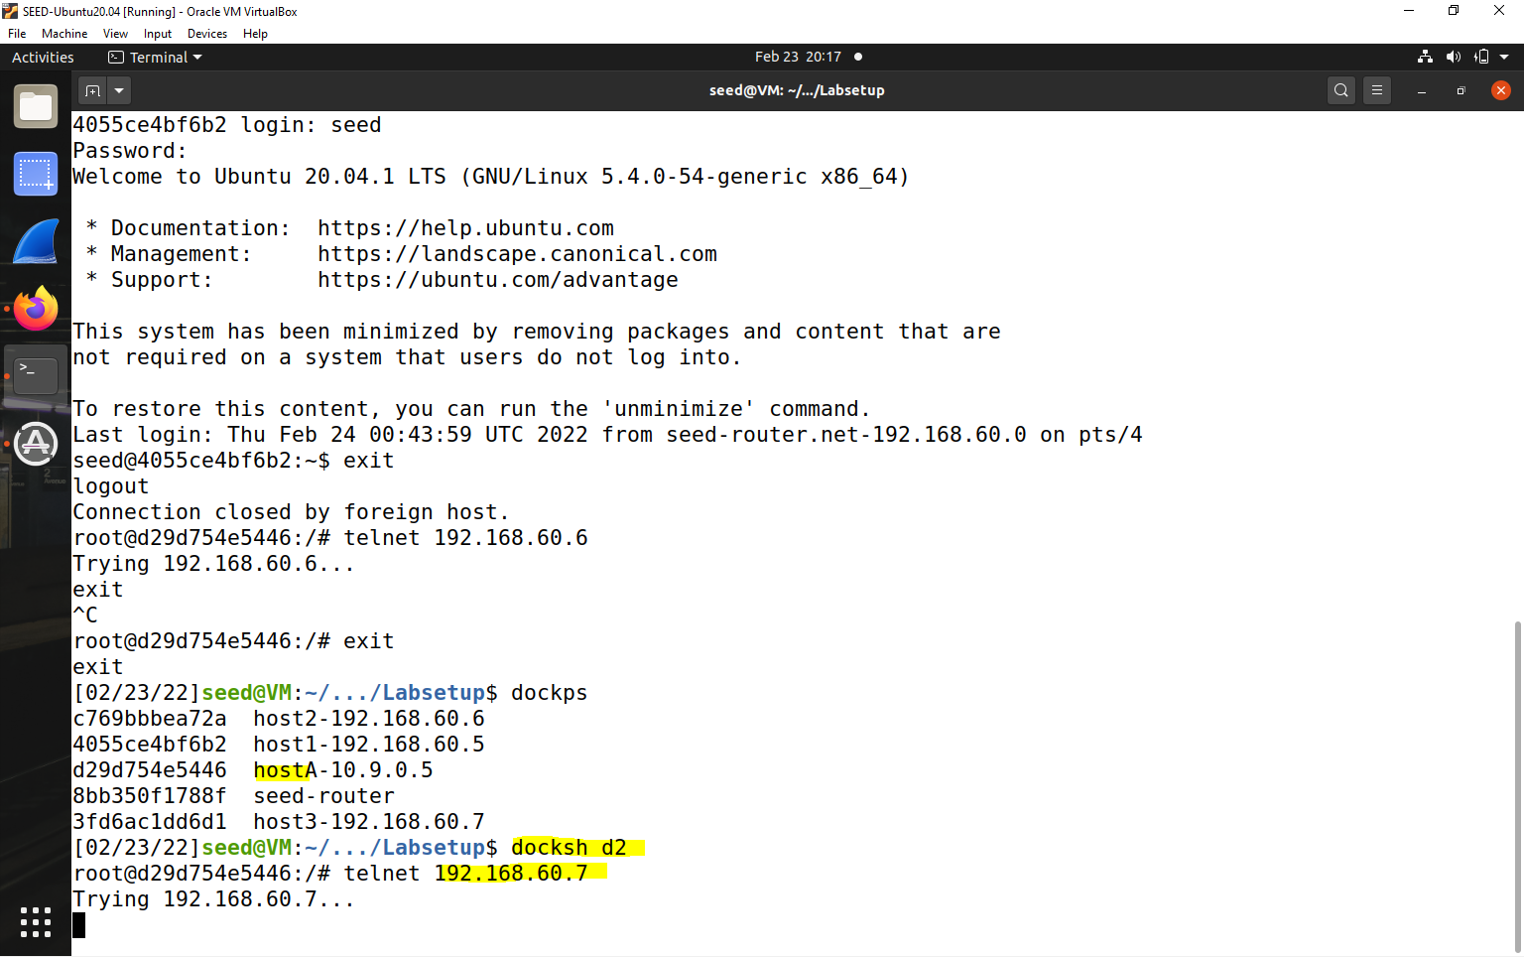



2. Outside hosts cannot access other internal servers.

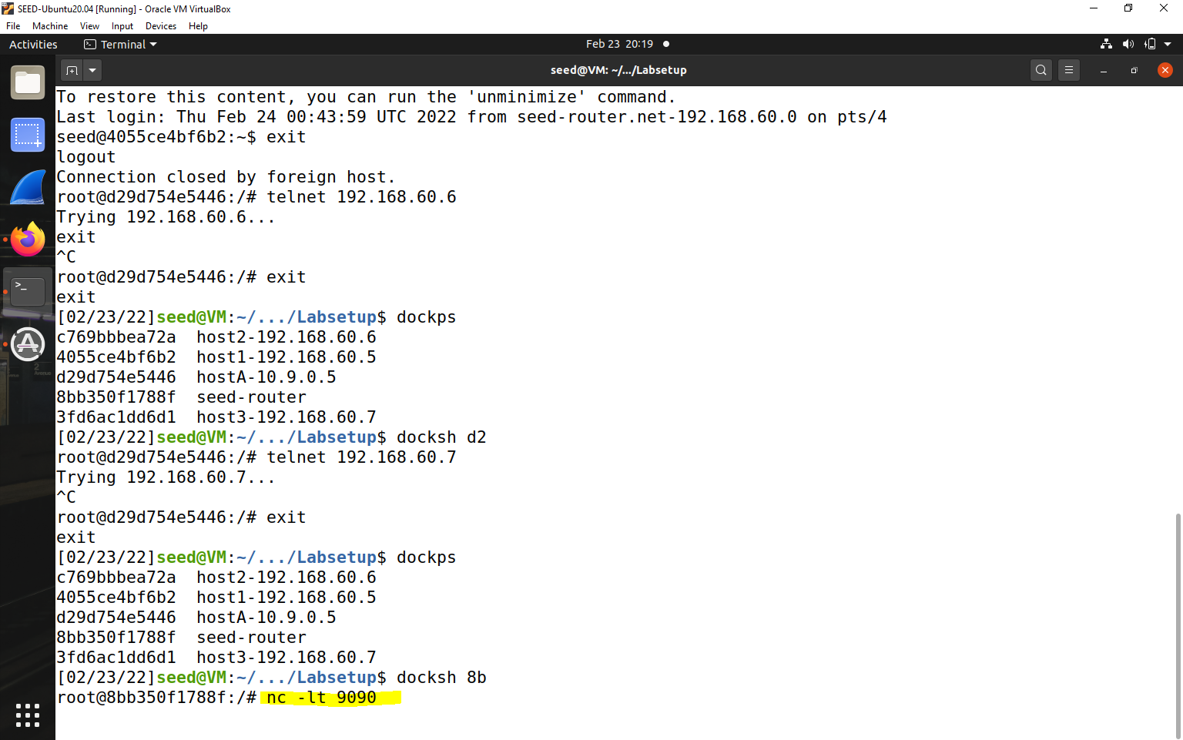



4.Internal hosts can access all the internal servers.

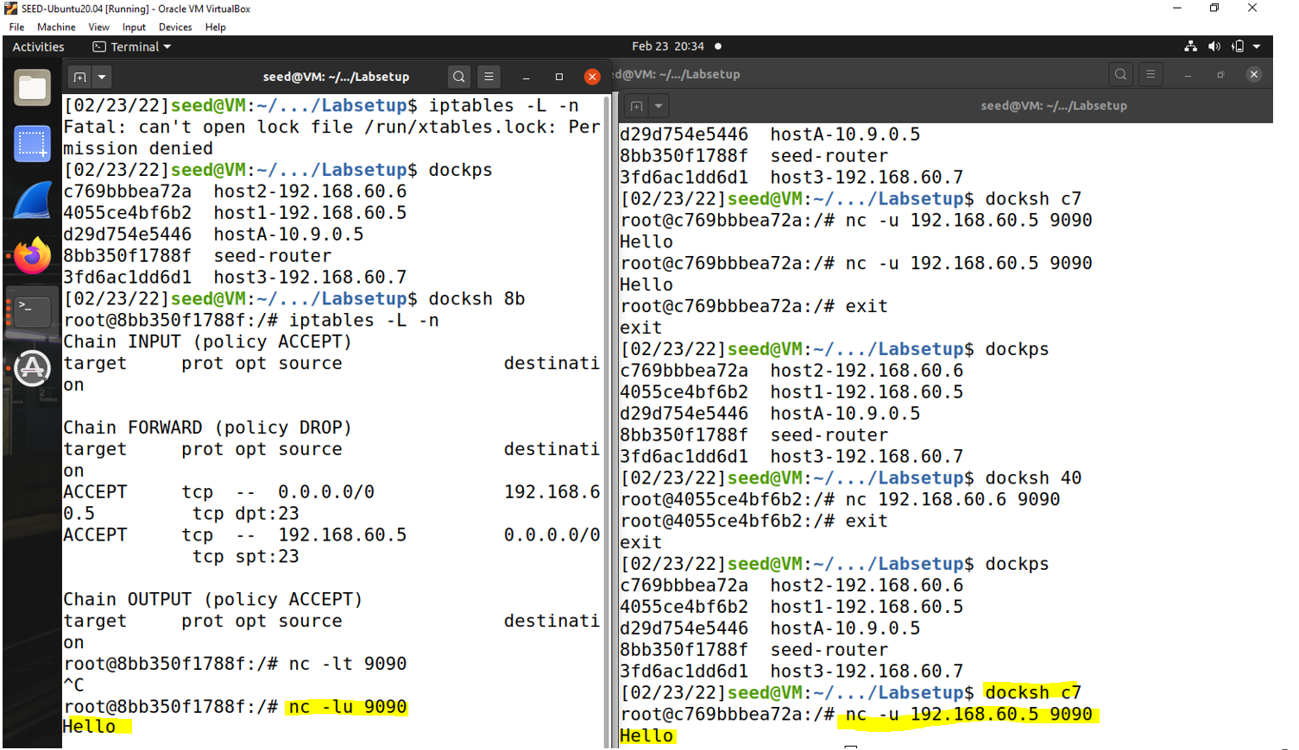



Internal hosts cannot access external servers.

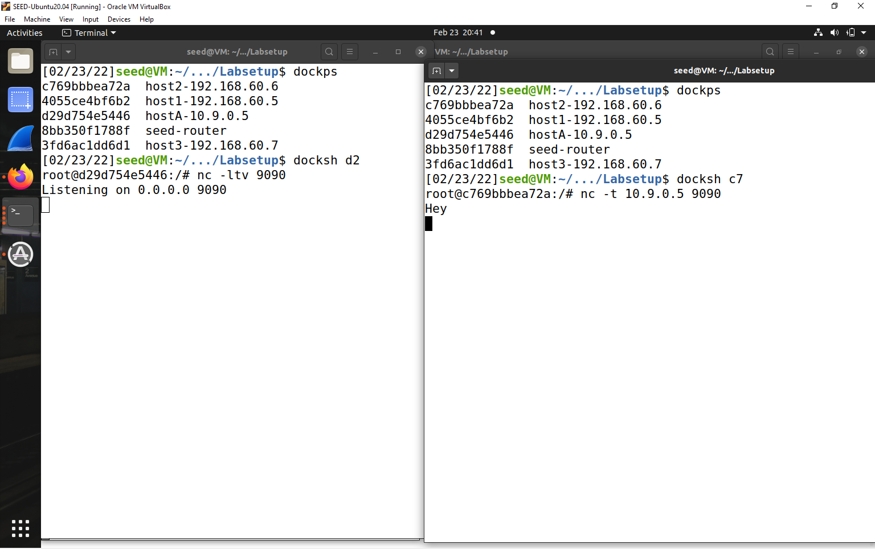

**Task 3.A: Experiment with the Connection Tracking:**

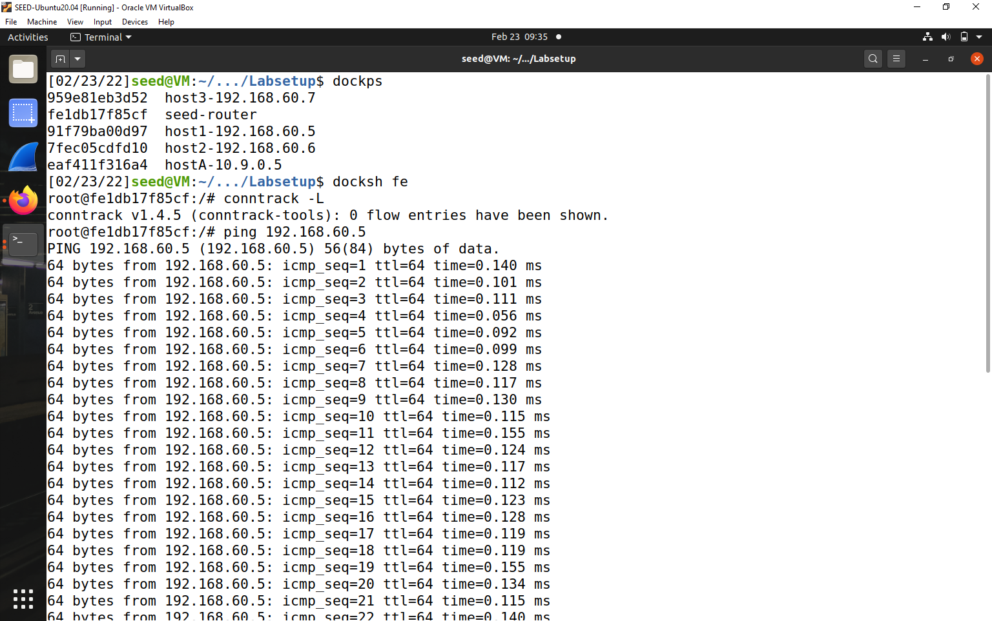

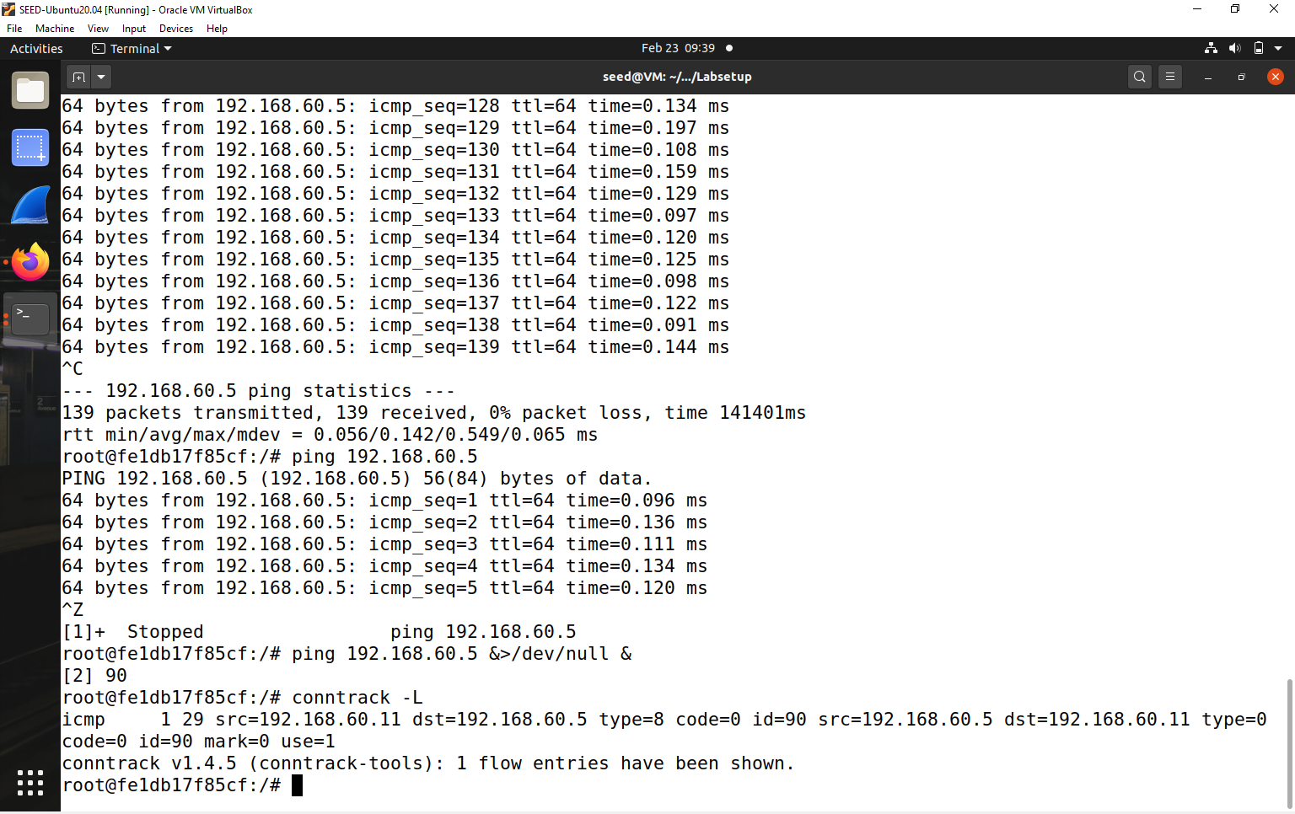

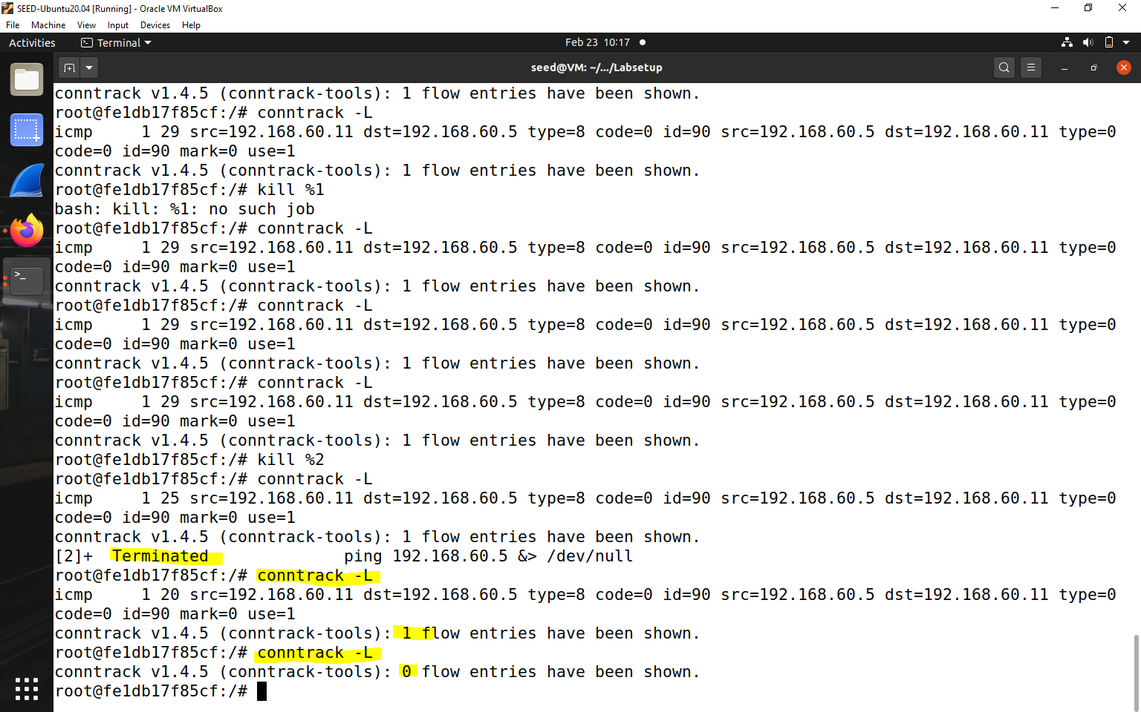



10.9.0.5 send out UDP packets –

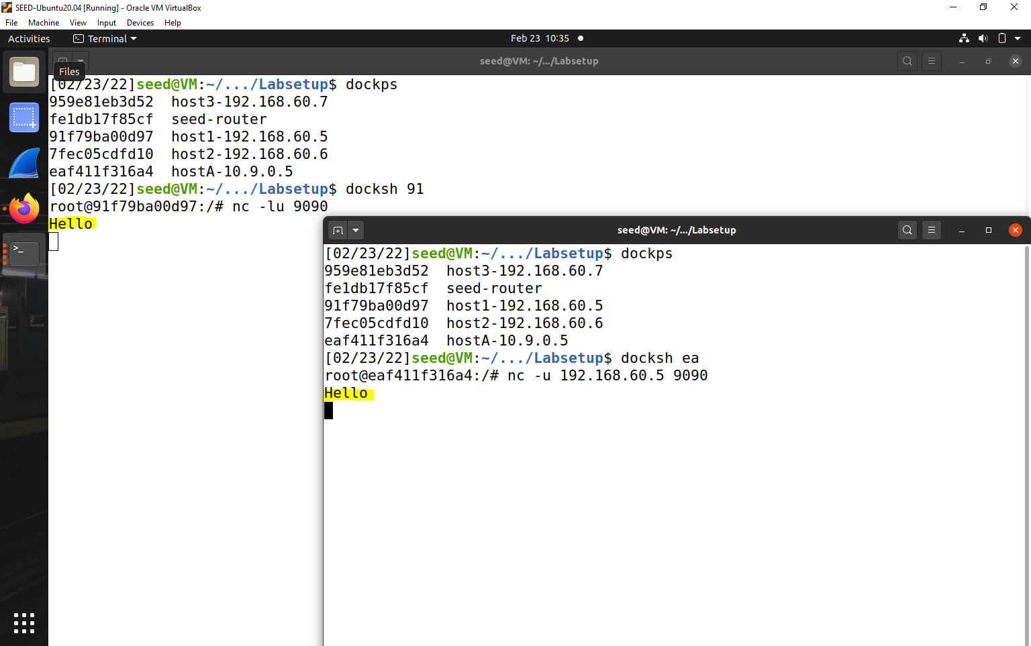



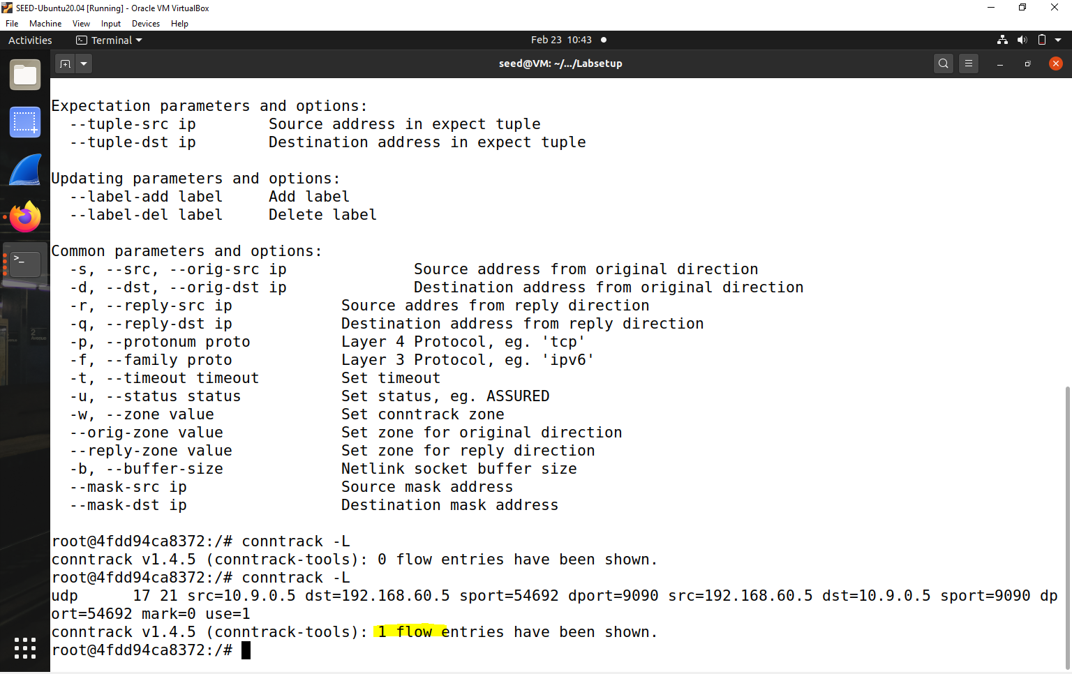



Describe your observation. How long is the UDP connection state be kept?

The ct system detects that it belongs to the same tracked connection and renews the timeout to another 30 seconds. Once the 30 seconds timeout expires, the ct garbage collector removes the tracked connection from the central ct table then adds it to the dying list and finally deletes it. If further UDP packets would keep coming on the same source and destination IP addresses and UDP ports, no matter which direction, then the ct system would assign all those UDP packets to the same tracked connection and this connection would not timeout as long as further packets would keep coming.

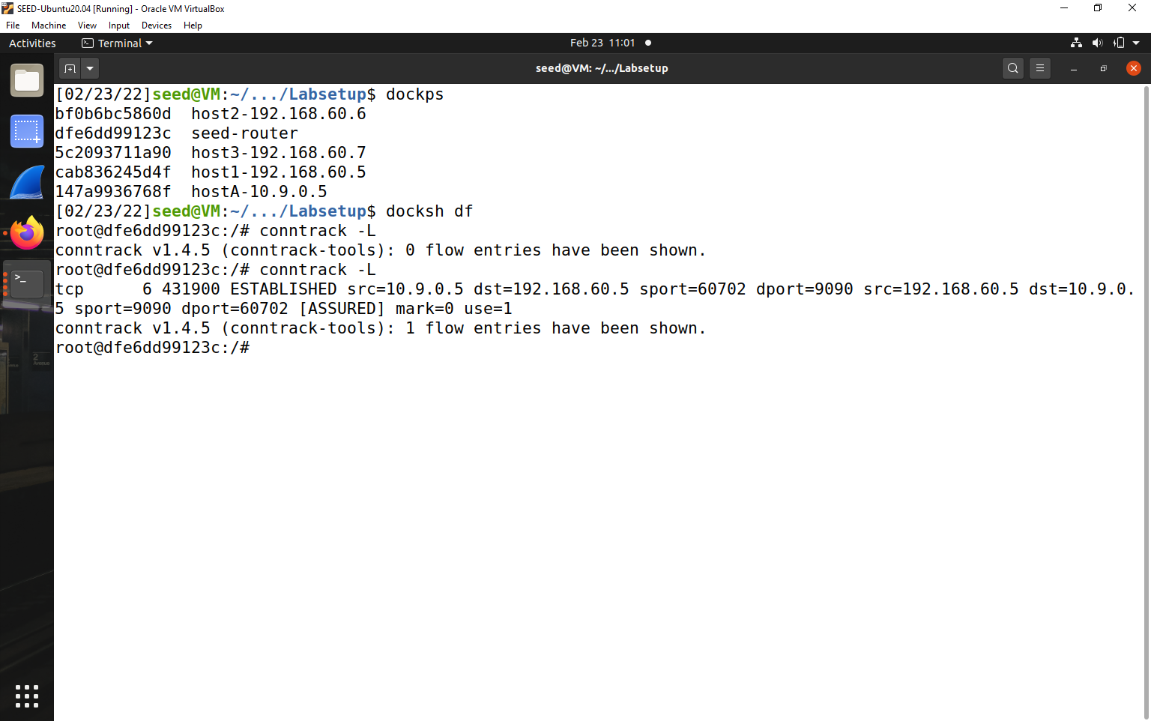

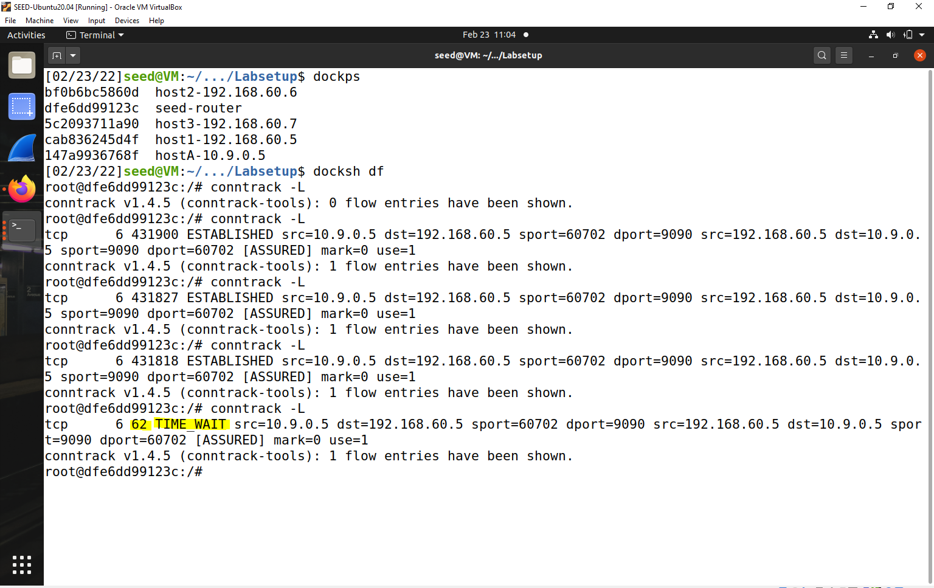



Atlast-

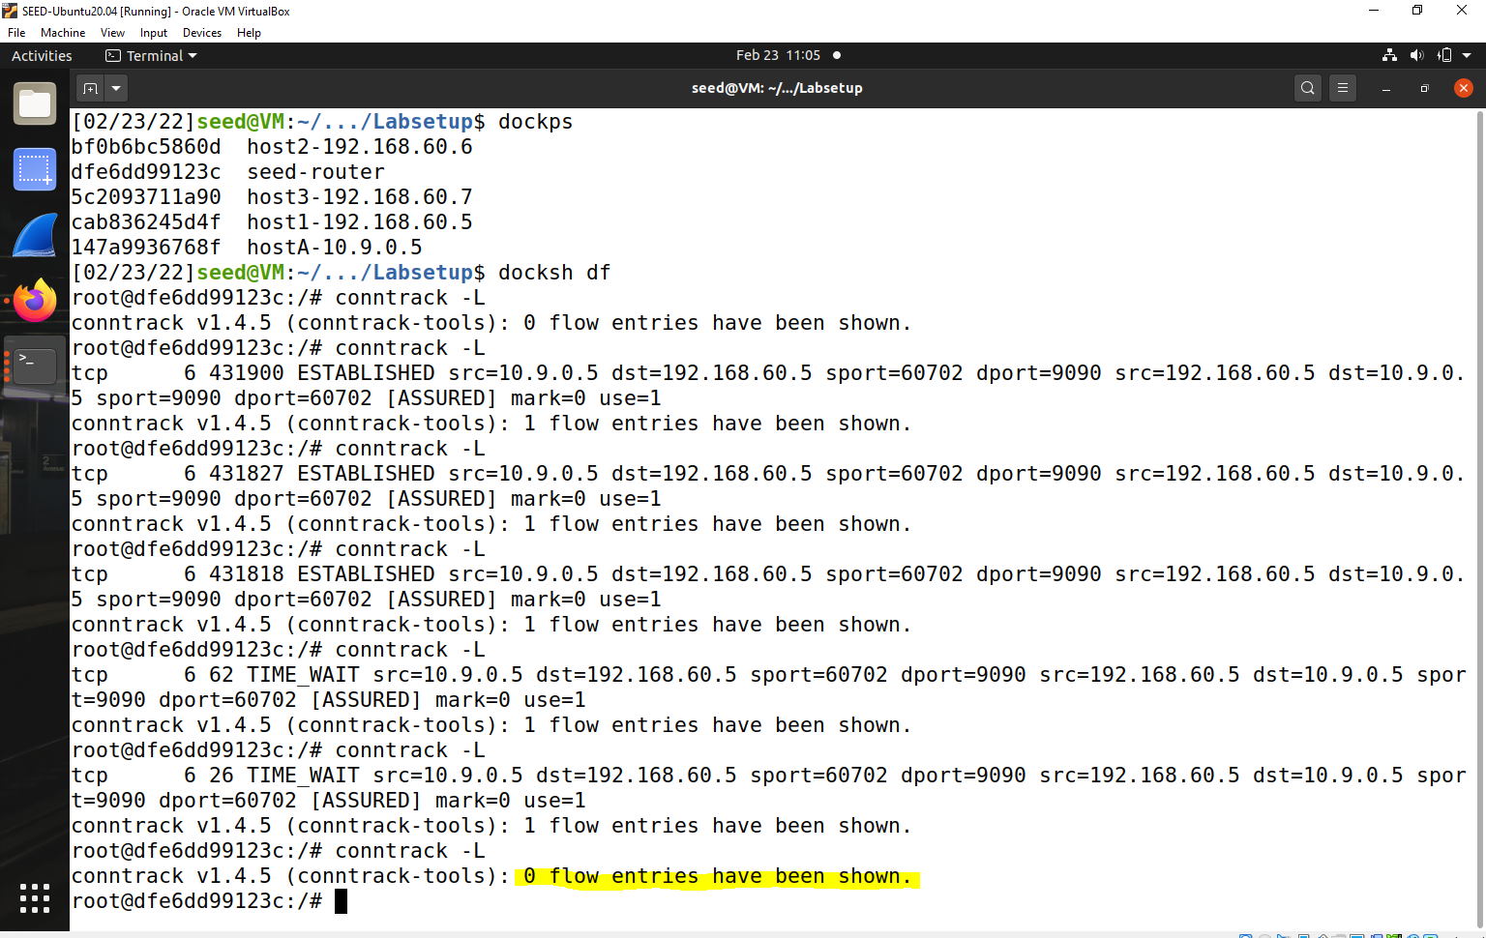



**Task 3.B: Setting Up a Stateful Firewall –**

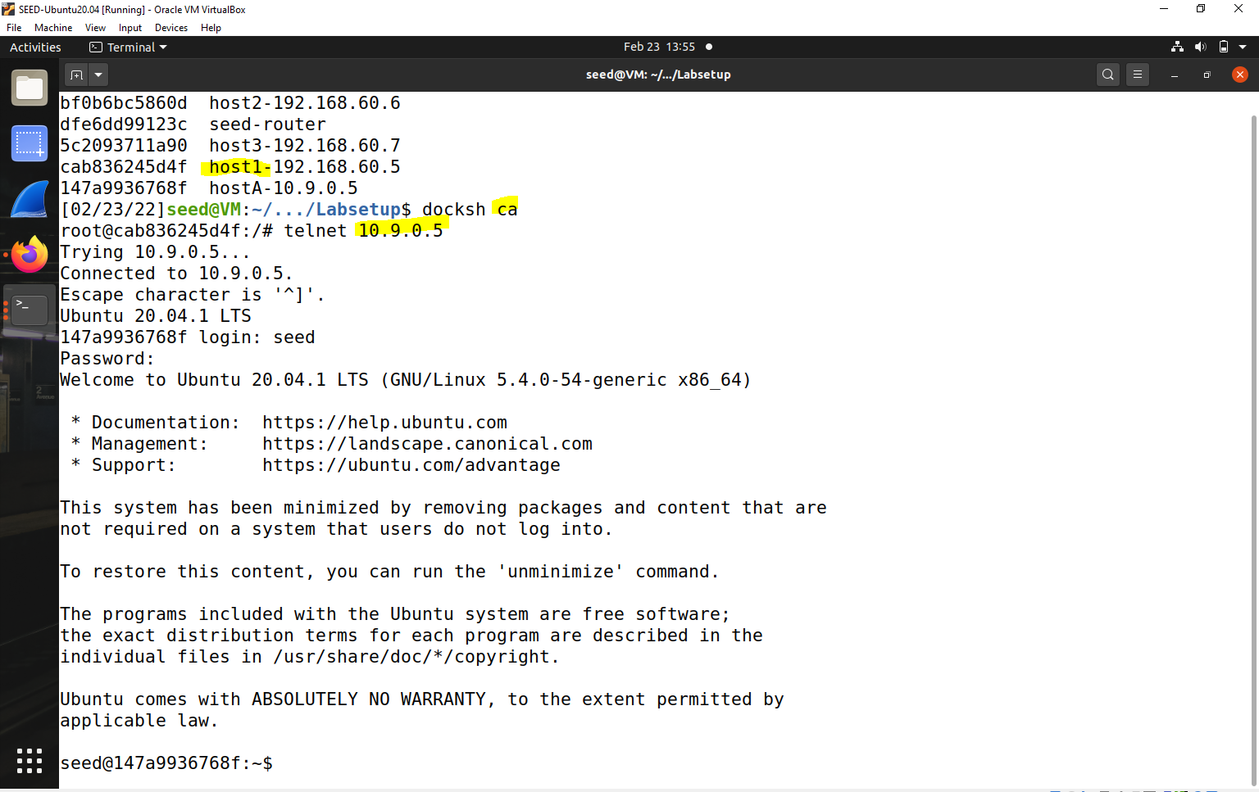



From 10.9.0.5 it is failing to connect

telnet from 10.9.0.5 to 192.168.60.5 – Connection is successful

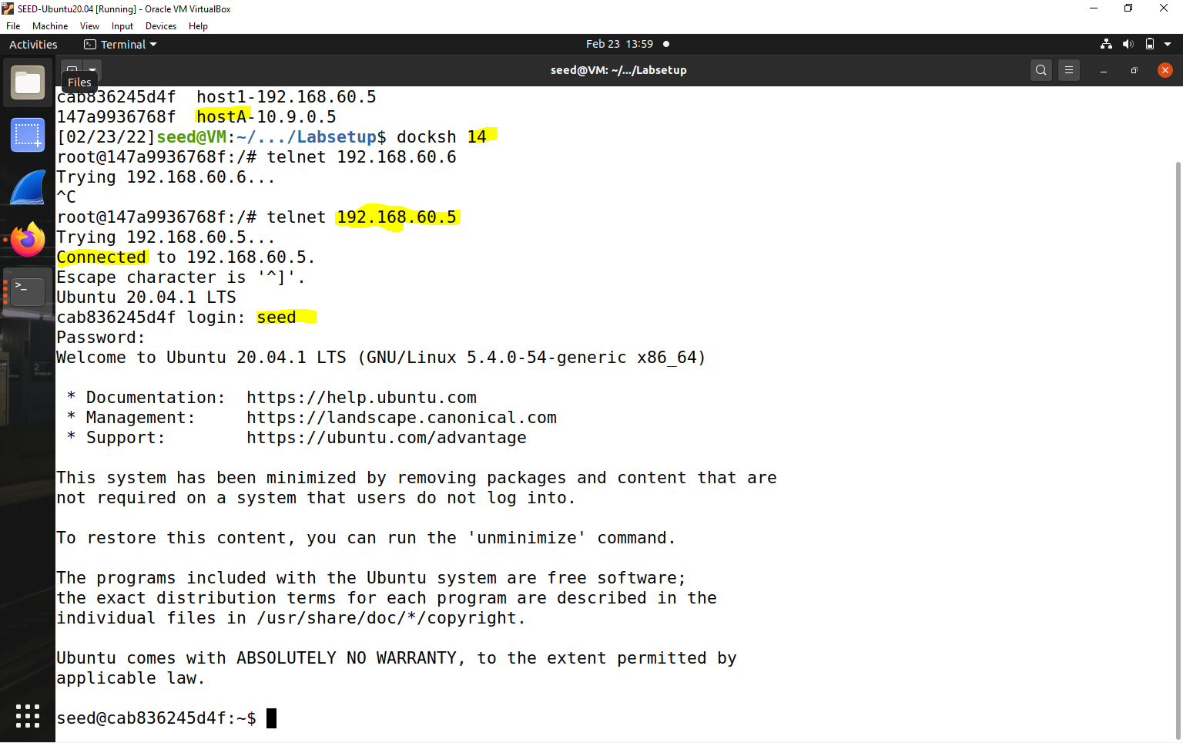



**Task 4: Limiting Network Traffic**

ping 192.168.60.5 from 10.9.0.5.

All packets are allowed

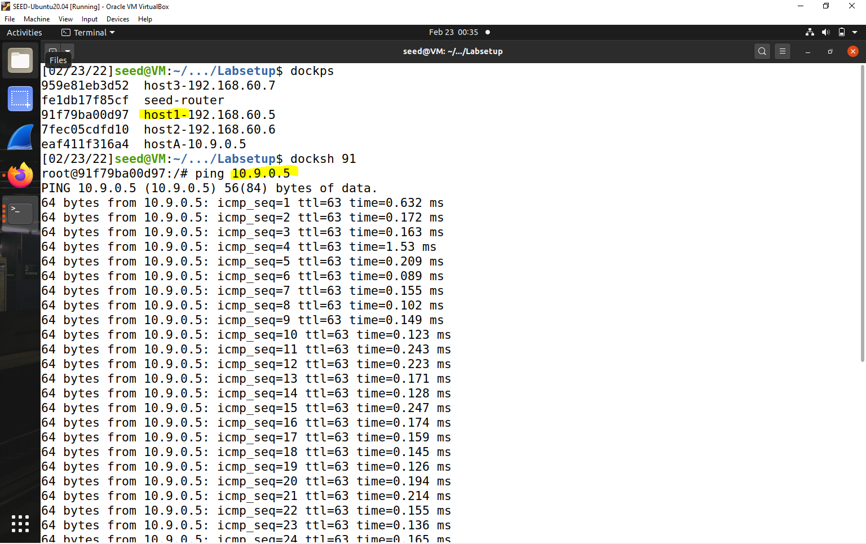



ping 192.168.60.5 from 10.9.0.5.

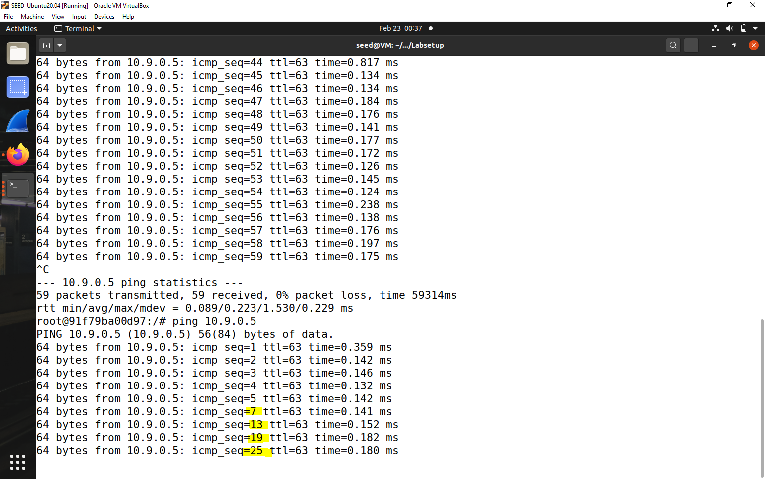



Rule matching is a fundamental topic to grasp. The first match wins when all iptables rules are checked in order. A limit rule, on the other hand, does not serve as a match. We may have a limit rule, followed by a packet-accepting rule. This can be perplexing. If we limit packets, we should follow it up with a rule that drops (or logs, then drops) additional packets of the same type.

**Task 5: Load Balancing**

**Iptables Equations -**

* iptables -t nat -A PREROUTING -p udp --dport 8080 -m statistic --mode nth --every 3 --packet 0 -j DNAT --to-destination 192.168.60.5:8080
* iptables -t nat -A PREROUTING -p udp --dport 8080 -m statistic --mode nth --every 2 --packet 0 -j DNAT --to-destination 192.168.60.6:8080
* iptables -t nat -A PREROUTING -p udp --dport 8080 -j DNAT --to-destination 192.168.60.7:8080

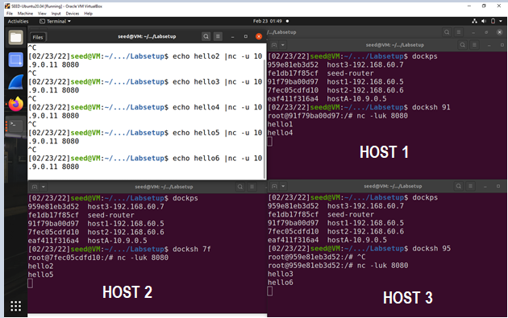

Host1-



Host 2-



Host 3-



**Using the randommode.**

* iptables -t nat -A PREROUTING -p udp --dport 8080 -m statistic --mode random --probability 0.333 -j DNAT --to-destination 192.168.60.5:
* iptables -t nat -A PREROUTING -p udp --dport 8080 -m statistic --mode random --probability 0.5 -j DNAT --to-destination 192.168.60.6:8080
* iptables -t nat -A PREROUTING -p udp --dport 8080 -m statistic --mode random --probability 1 -j DNAT --to-destination 192.168.60.7:8080
* 